World Renewable Energy Analysis

Mourya Kakarapu1, Aayushi Sinha2, Santhosh Naik3

*Department of Computer Science and Engineering, Indian Institute of Information Technology Dharwad, 580009, India*

# Article Info

Keywords: Renewable Energy; Hydropower; Solar; Wind; Geo biomass; Energy Generation

# Abstract

This report offers an in-depth examination of the global renewable energy sector, emphasizing a comparative analysis of India's standing relative to other nations, continents, and economic categories. By employing a range of data analytics methodologies such as statistical evaluations and advanced visualization techniques, the analysis delves into the geographical spread and the socioeconomic factors influencing renewable energy. It also explores the contributions of different technologies to the sector and projects future trends in the adoption of renewable energies. Specifically, the study sheds light on India's advancements and the obstacles it faces in the deployment of renewable energy solutions. It provides detailed insights into how income levels affect renewable energy utilization, the prominence of various technologies within this sphere, and the regional differences that exist. Through this comprehensive analysis, the report aims to furnish stakeholders with a clearer understanding of the dynamics shaping the renewable energy landscape, thereby facilitating informed decision-making and strategic planning in the context of global and national energy policies.

# 1. Introduction

The urgency of transitioning to renewable energy sources is imperative in the global effort to combat climate change and promote energy sustainability. This report provides a thorough analysis of the worldwide renewable energy landscape, focusing particularly on India's role within the global context as compared to other nations, continents, and different economic strata. The data utilized in this study covers a wide array of renewable energy sources such as hydropower, solar, wind, geothermal, and biomass energies. These sources are examined across diverse geographical regions and socioeconomic backgrounds to provide a holistic view of their distribution and impact. By analyzing the proportion of energy derived from these renewable sources, we aim to highlight the progress made by various countries in integrating sustainable energy practices. We also seek to identify patterns and trends that could inform policy decisions and strategic initiatives aimed at enhancing the adoption of renewable energy technologies.

## 1.1. Scope of Analysis:

1. Detailed Analysis of India's Renewable Energy Landscape: Offering a comprehensive and comparative analysis of India's renewable energy landscape against global counterparts, highlighting its achievements, challenges, and future prospects.
2. Geographical Comparison: Examining the distribution of renewable energy shares among different countries and continents to identify regional trends and disparities.
3. Socioeconomic Perspective: Investigating how income levels influence the adoption and utilization of renewable energy sources.
4. Technology Analysis: Assessing the contribution of different renewable energy technologies, such as hydro, solar, wind, geothermal, and biomass, towards the overall energy portfolio.
5. Forecasting Future Trends: Utilizing predictive analytics models to forecast the trajectory of renewable energy adoption globally, regionally, and within specific countries.

## 1.2. Objectives

The report presents several key findings, including:

1. India's progress in renewable energy deployment compared to global benchmarks.
2. The impact of income levels on the proportion of renewable energy in the energy mix.
3. The prominence of certain renewable energy technologies in different regions.
4. Regional disparities in renewable energy adoption and policy frameworks.

# 2. Literature Review

The global shift towards renewable energy sources is an undeniable necessity, driven by the urgent need to combat climate change and achieve long-term energy sustainability. This literature review explores a variety of resources that illuminate the multifaceted considerations surrounding renewable energy adoption, encompassing technical advancements, societal impacts, and policy frameworks.

Scientific articles published in ScienceDirect by Yolcan et al. [1], Tze-Zhang Ang et al. [2], and Md Kashif Gohar Deshmukh et al. [10] delve into the technical aspects of renewable energy technologies. These resources explore advancements in wind turbine efficiency, solar panel material science, and geothermal extraction techniques, all of which are propelling the global energy shift. The articles also analyze the challenges associated with integrating these diverse renewable sources into existing electrical grids, while considering their environmental impact.

Research papers extend the discourse beyond just technical aspects. For instance, the work by Grzegorz Mentel et al. [9] explores the social and economic impacts of renewable energy adoption. It examines policy frameworks that incentivize individuals and communities to make the switch to renewable sources and analyzes how such a transition affects energy security on a national or regional level.

Blog posts and industry reports offer valuable additional insights into the global renewable energy transition. A blog post by HamoYehq [6] discusses challenges encountered during the transition, such as public perception or infrastructure limitations, and explores potential solutions for overcoming them. Industry reports from Mordor Intelligence [7] provide industry-specific analyses and forecasts for the renewable energy market, while S&P Global [8] offers data-driven insights into renewable energy adoption across various regions.

Some resources, like the research paper on the current status and future potential of renewable energy in India by Ashwani Kumar et al. [4], can provide valuable insights specific to the Indian subcontinent. Similarly, reports by S&P Global [8] that focus on Indian renewable energy data analytics can offer a deeper understanding of the challenges and opportunities in this particular region.

By examining this range of resources, we gain a comprehensive understanding of the multifaceted nature of renewable energy adoption. This knowledge is essential for informing future research and efforts to achieve a sustainable energy future.

# 3. Proposed Method

We have used various data analytics techniques, including statistical analysis and visualization tools to extract meaningful insights from the data set. Various visualization techniques such as charts, graphs, and maps have been utilized to illustrate trends, patterns, and correlations within the data. We have used SQL for data cleaning and manipulation as well as Tableau, Power BI and Pandas for data visualization.

# 4. Experimental Analysis

The experimental analysis focuses on several key objectives, including India's progress in renewable energy deployment compared to global benchmarks, the impact of income levels on the proportion of renewable energy in the energy mix, the prominence of certain renewable energy technologies in different regions, and regional disparities in renewable energy adoption and policy frameworks. Through predictive analytics models, the report forecasts future trends in renewable energy adoption globally, regionally, and within specific countries.

## 4.1 Data set:

1. Renewable Energy Dataset: <https://www.kaggle.com/datasets/belayethossainds/renewable-energy-world-wide-19652022/data>
2. India’s GDP: <https://data.worldbank.org/indicator/NY.GDP.MKTP.KD.ZG?locations=IN&most_recent_year_desc=false>

# Results and Analysis

## 1. Renewable Energy Share

Dataset used : [01-renewable-share-energy.csv](https://www.kaggle.com/datasets/belayethossainds/renewable-energy-world-wide-19652022/data?select=01+renewable-share-energy.csv)

The Dataset contains the following columns:

* **Entity:** Contains 104 different regions (countries, continents, income brackets)
* **Code:** Contains region codes.
* **Year:** In the range 1965 - 2021
* **Renewables (% equivalent primary energy):** Represents the percentage of renewable energy in total energy for that region and year.

### a. World Renewable Energy Share: By Countries

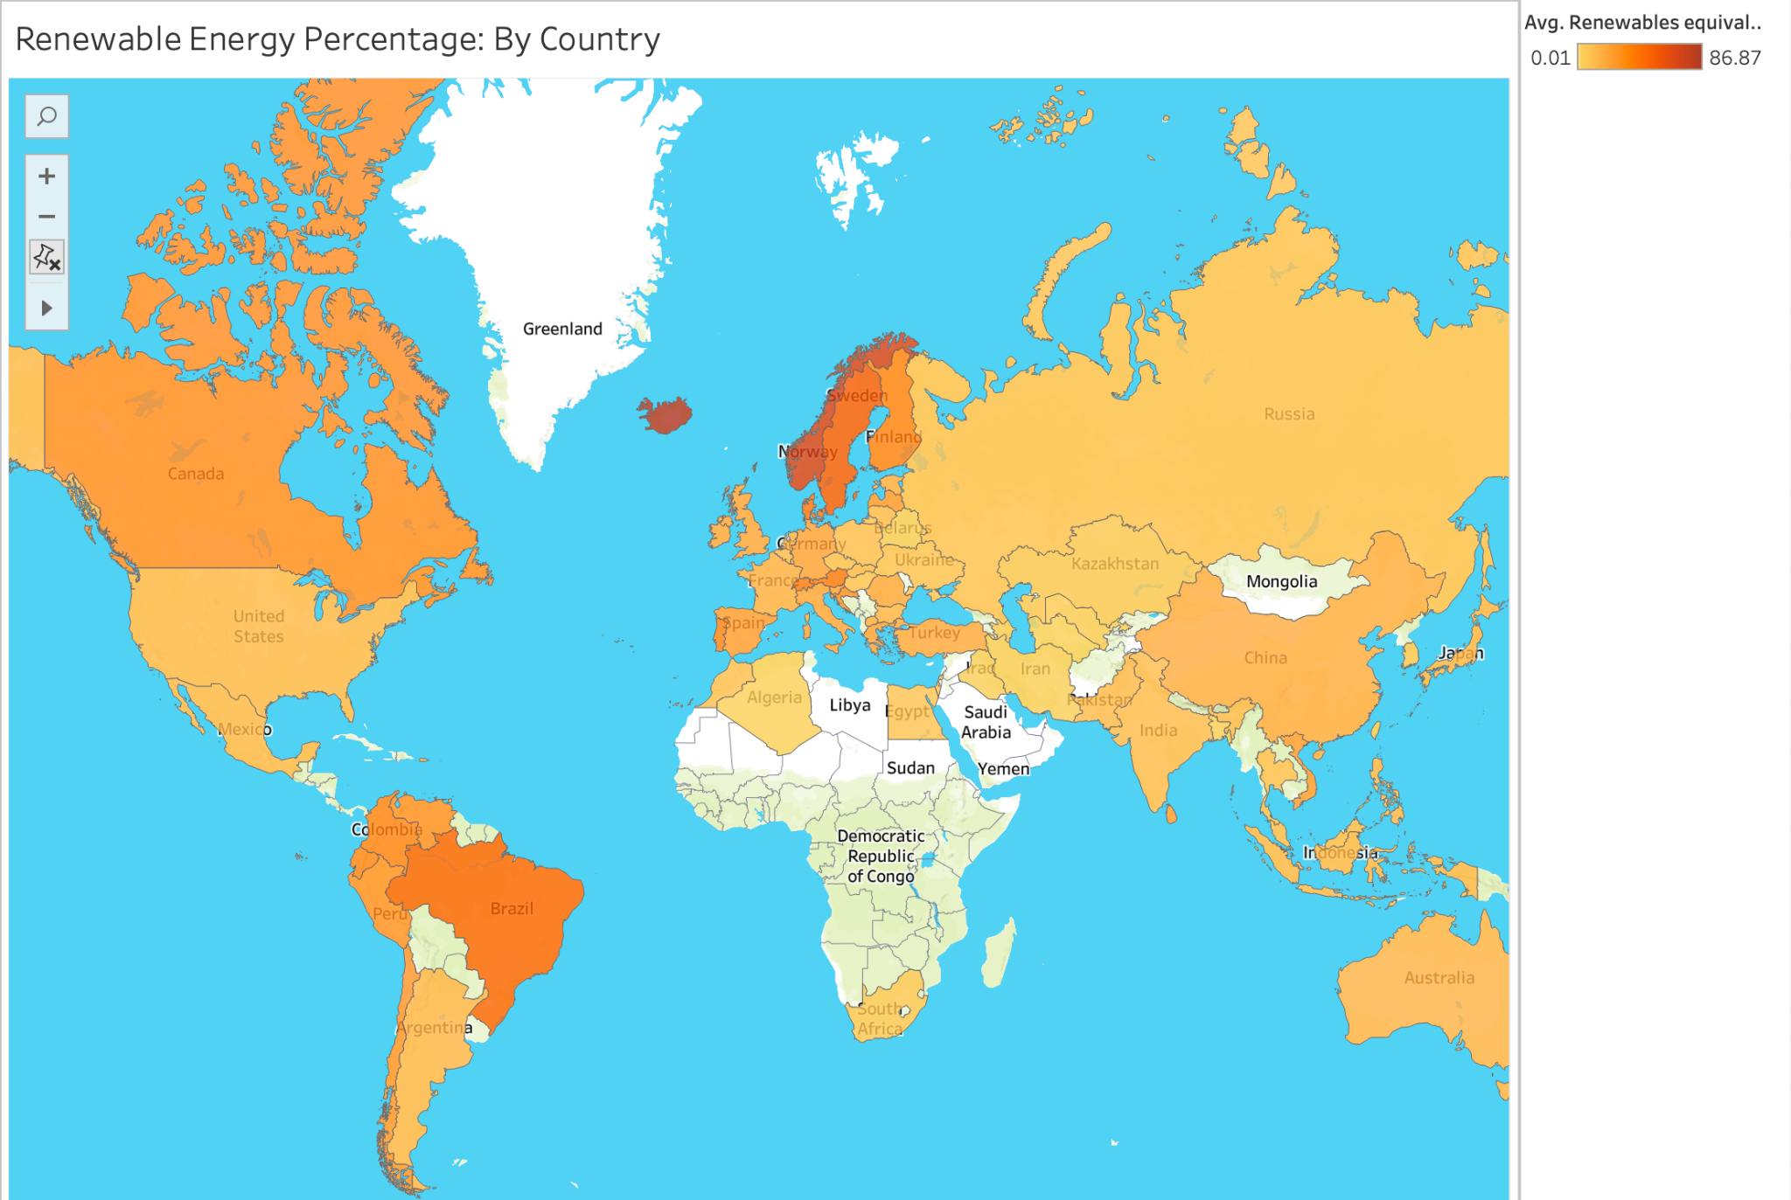

This visualization presents a world map illustrating the distribution of renewable energy shares across different countries. Each country is color-coded based on its percentage share of renewable energy in the total energy mix.

The map highlights significant disparities in renewable energy adoption globally. For instance, European countries like Norway and Iceland exhibit high renewable energy shares, while countries in Africa and parts of Asia lag behind.

We can clearly observe that India does not have a very significant share along with all countries in Asia. If you look into the numbers, as of 2021 - latest available data in the dataset - India’s Renewable Energy Percentage is 9.31%

### b. Renewable Energy Share: By Continents

This area chart displays the historical trends of renewable energy shares for different continents over the years. Each continent is represented by a distinct coloured area, with the x-axis denoting the years and the y-axis representing the percentage share of renewable energy in the total energy mix.

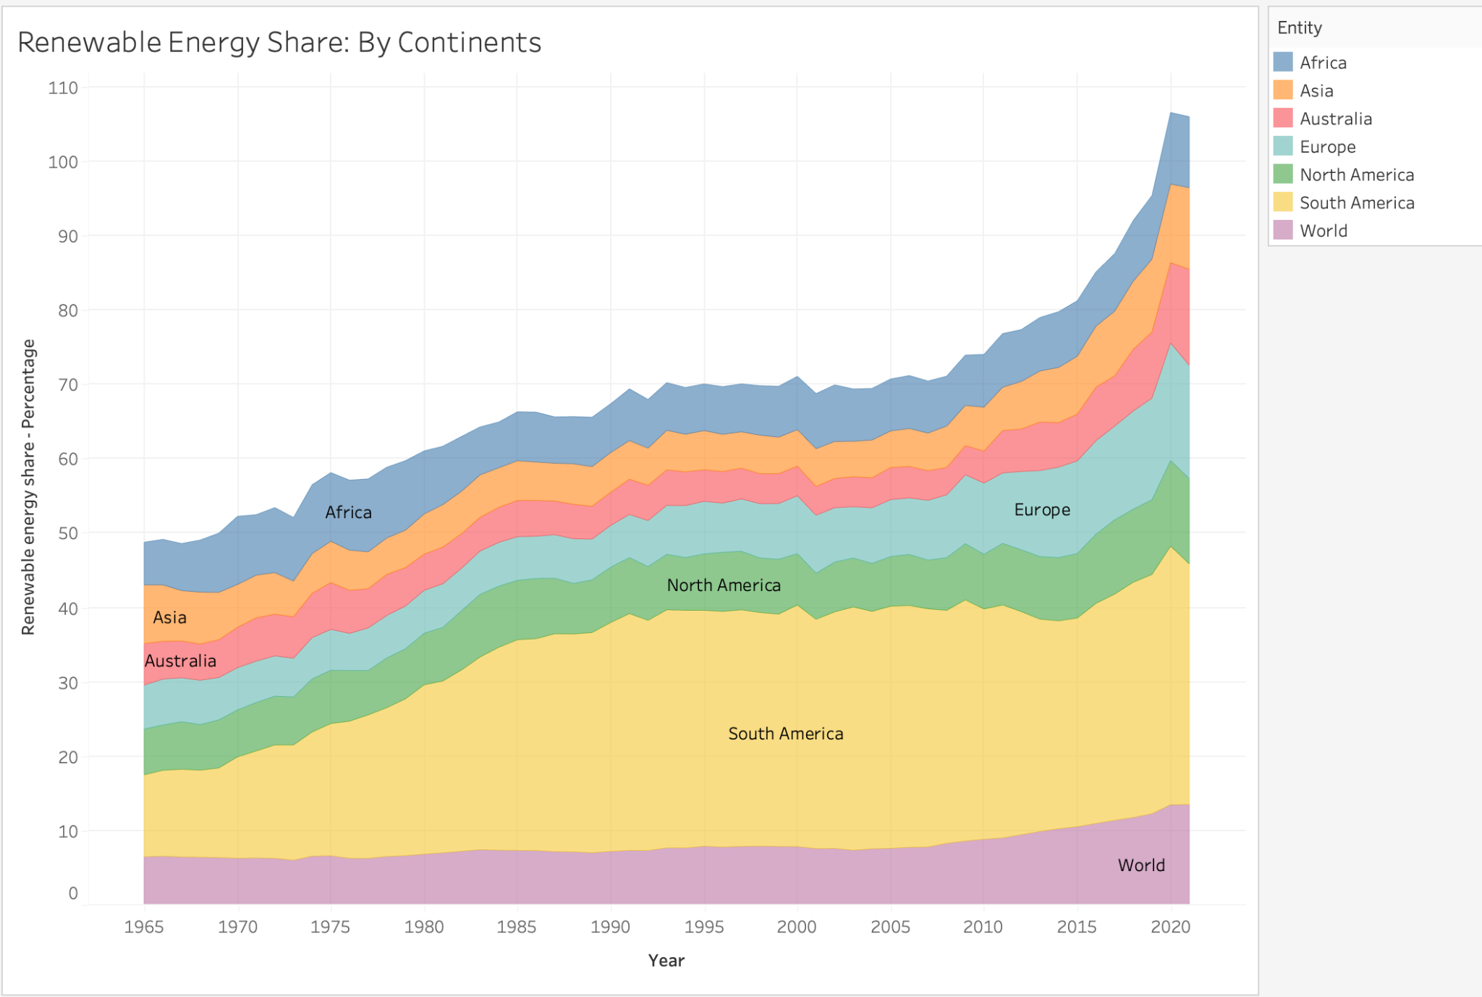

South America is by far the highest shareholder, which says great things about the continent as they are the biggest contributors towards a sustainable future.

This is because Latin America (South and Central America) have an abundance of natural resources such as strong winds, and vast hydro power potential from rivers like the Amazon. Many Latin American countries have implemented policies that favor renewable energy development.

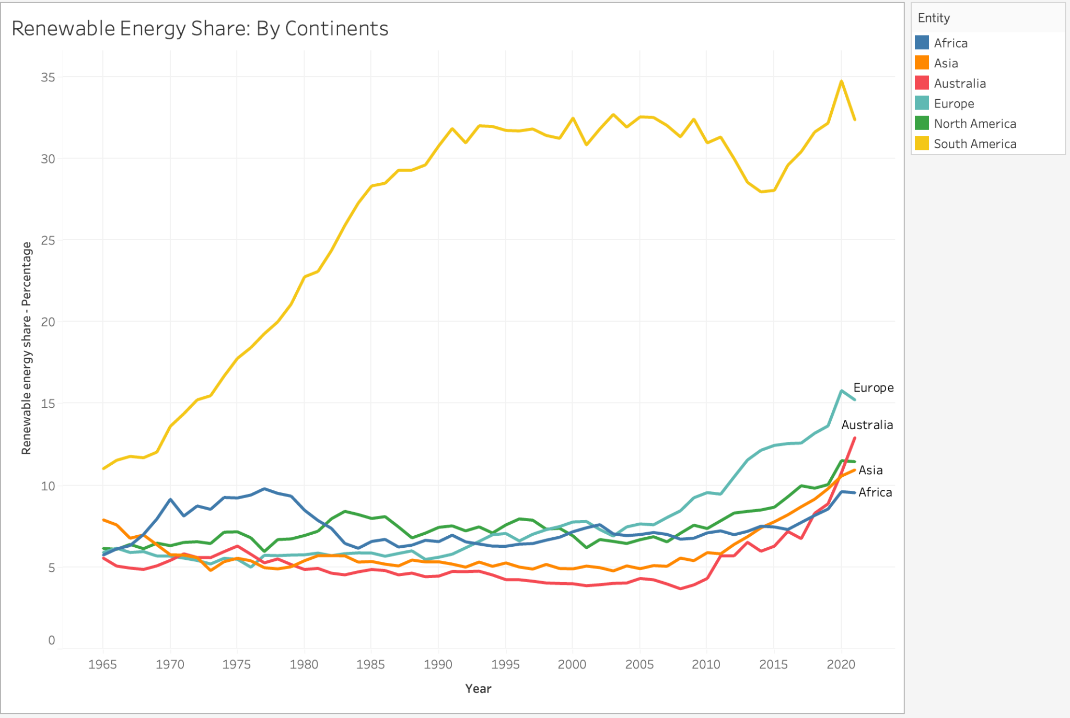

**c. Renewable Energy Share: By Income**  
This line chart compares the historical trends of renewable energy shares among countries categorized into lower middle income, upper middle income, and high-income groups over the years. Each income group is represented by a distinct line on the chart, with the x-axis denoting the years and the y-axis representing the percentage share of renewable energy in the total energy mix.  
 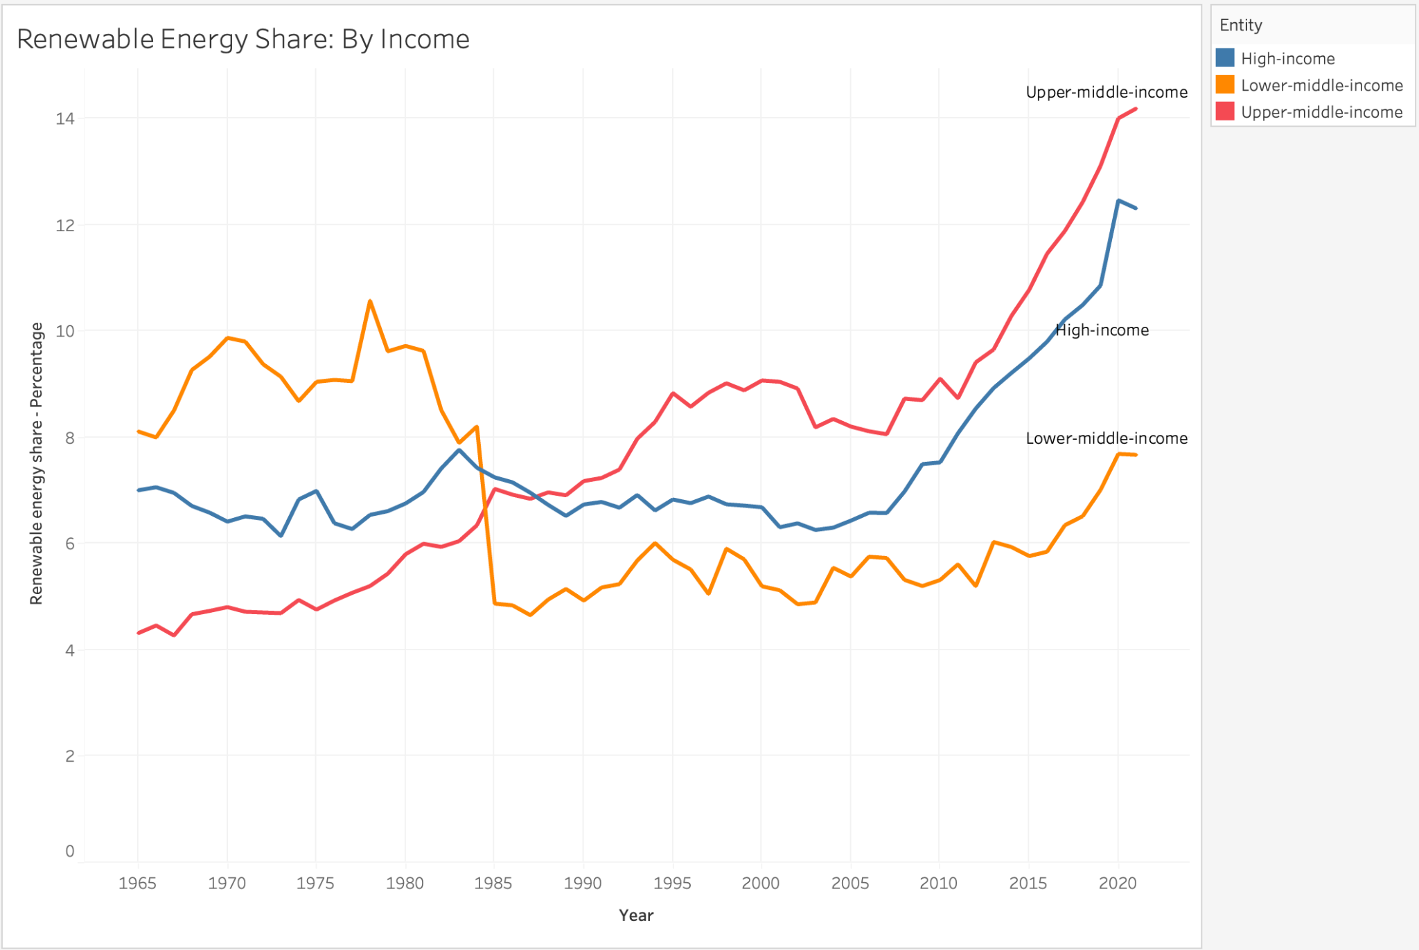

**1. Lower Middle Income:**

Countries such as **India, Pakistan, Ukraine, Sri Lanka, Nigeria** come under the lower middle income bracket. We can observe a steady increase in the renewable energy share in the last 35 years, after a sharp decline from 8.20% in 1984 to 4.87% in 1985. This drastic dip from having the highest energy share to the lowest share was marked by the Fossil Fuel boom and the focus on Industrialization in the 1980s. As of 2021, they are at 7.67%.

**2. Upper Middle Income:**

Countries such as **China, Iran, Iraq, Brazil and most of the South American countries** come under the upper middle income bracket. We can observe that their trend has only been increasing, especially since 2011, where we can observe a drastic increase. From 8.73% in 2011 to 14.18% in 2021, also being the highest in the world as of 2021. This is likely because of the abundance of natural resources, improvement in policies and technology and economic development in these countries.

**3. High Income Countries:**

Countries such as the **United States, United Kingdom, Iceland, Japan, Russia, Germany and most of the European countries** come under the high income bracket. Even if higher-income countries have a lower total share currently, their rapid growth in the renewable sector recently (since 2010) is significant. They had a significant bump from 7.53% in 2010 to 10.55% in 2018 and an even steeper increase to 12.45% in 2020. Their relative lower share is due to the factor that developed countries have been historically dependent on fossil fuels and have a lower population density, leading to less consumption of energy overall.

### d. Where India Stands:

This set of line charts compares India's renewable energy share with various benchmarks, providing insights into India's position relative to the world and key countries such as China, the USA, Iceland, and Norway. It is to be noted that Iceland and Norway have been included as they are the top 2 countries in renewable energy share and provide more perspective as to where other countries stand. Each line chart depicts the trends of renewable energy shares over time, with the x-axis representing the years and the y-axis denoting the percentage share of renewable energy in the total energy mix.

#### i) India vs World:

This line chart compares India’s renewable energy share against the global average. By observing the trend lines, we can notice that India was way ahead of the global average back in 1965 and peaked its renewable energy share around 1980 - in 1978, to be precise - at 14.82% showcasing significant progress and commitment towards renewable energy adoption. But after that there has been a steep decline, and eventually the global average surpassed that of India in 1995 and it has stayed that way ever since. This clearly highlights the need for renewed efforts and strategic interventions to regain momentum and align with global sustainability goals. As of 2021, India is at 9.31%, leaving lots of room for improvement.

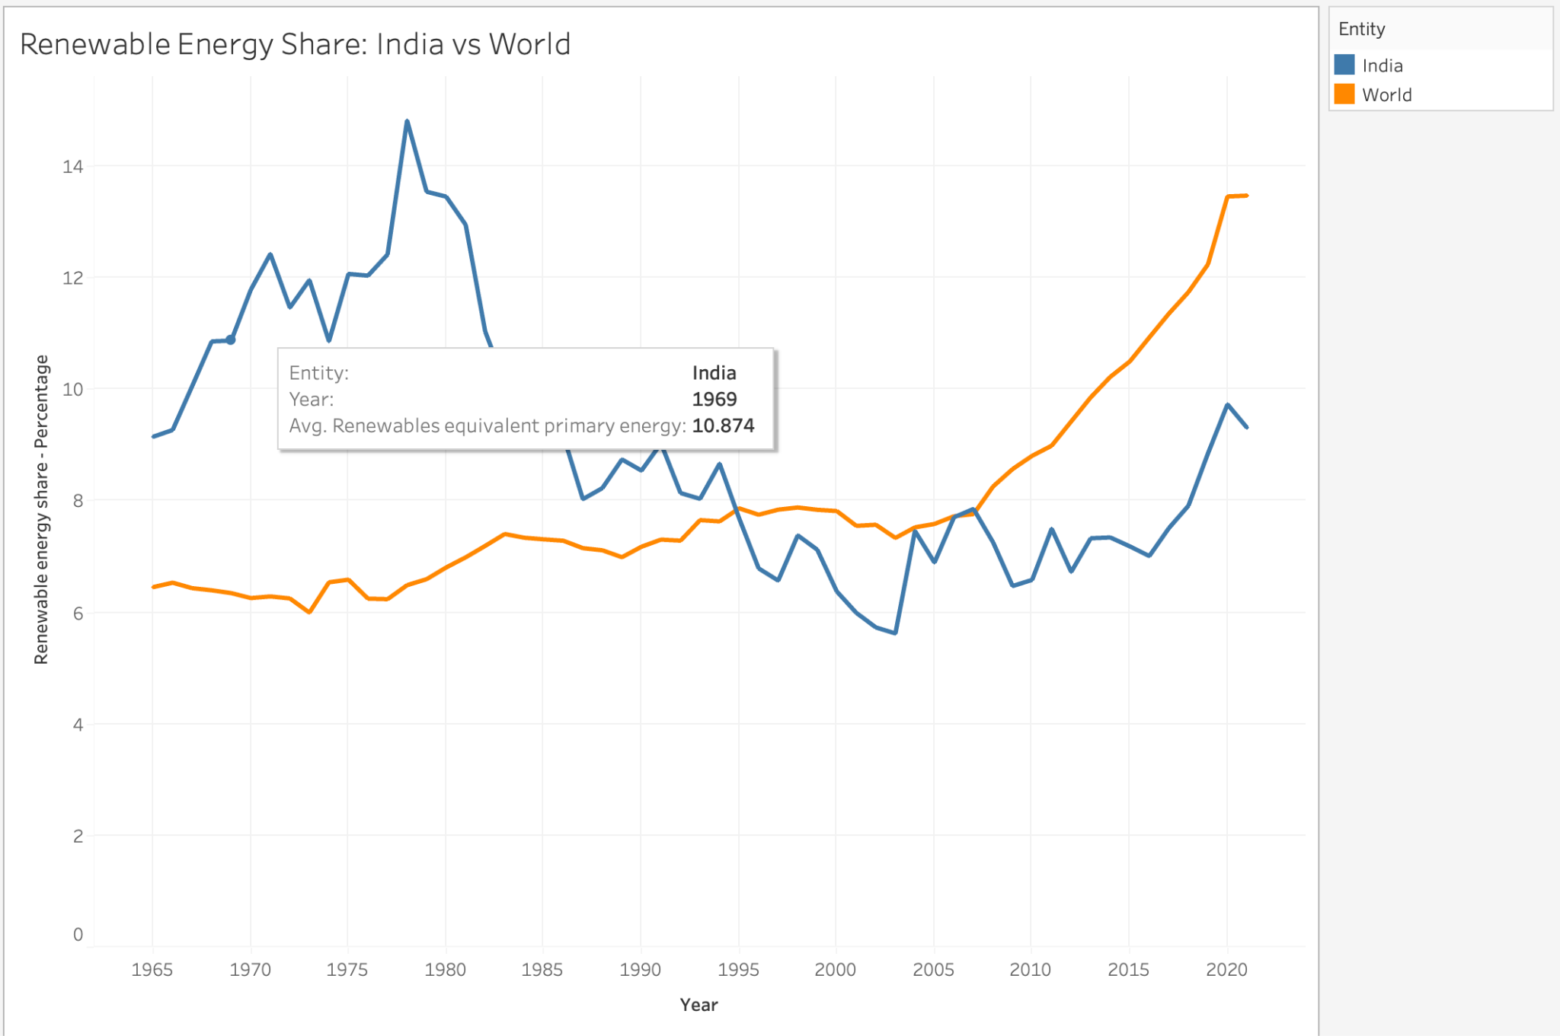

#### ii) India vs China vs USA:

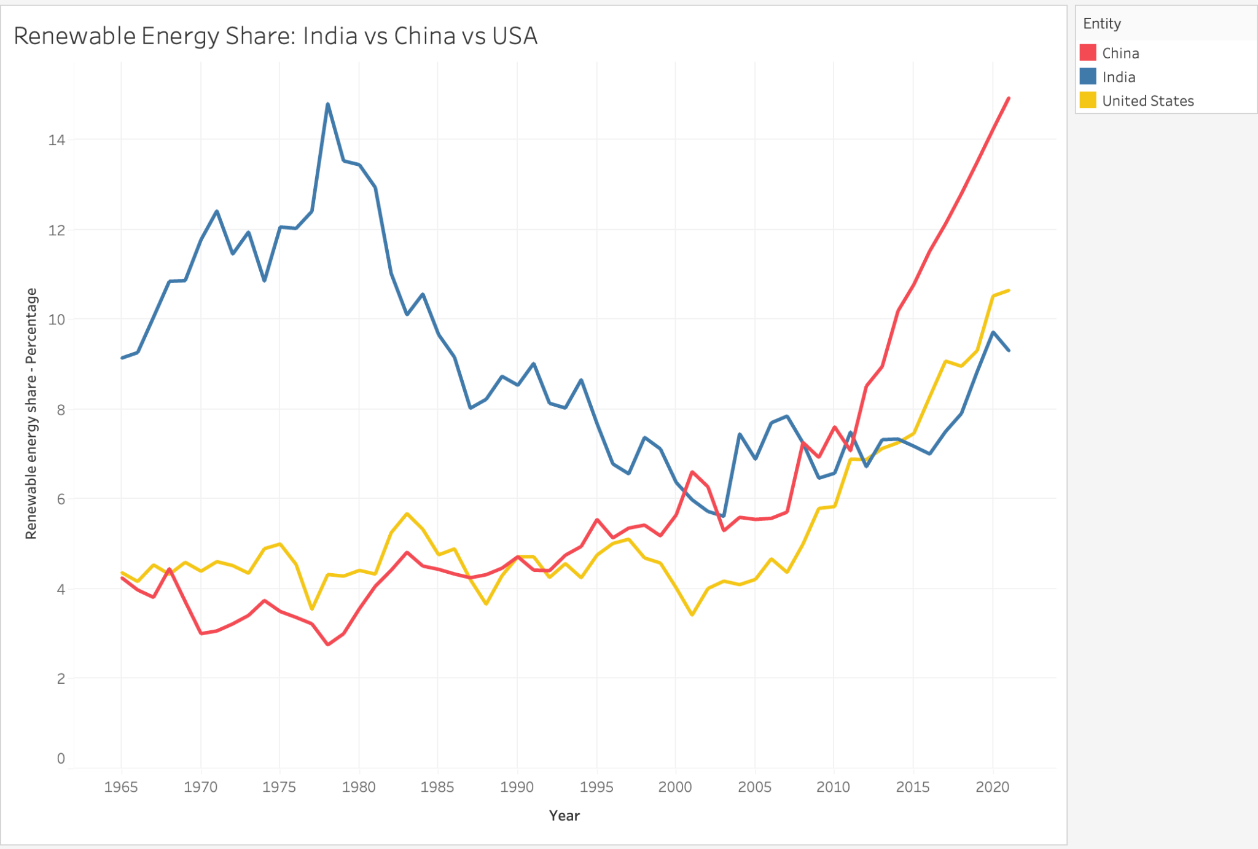

This second line chart offers a comparative analysis of India's renewable energy share with two global powerhouses: China and the USA. It can be observed that historically, India was ahead of both these countries and China was the lowest but with time, China eventually overtook India around 2000 and USA also did so around 2010. Another important observation is China’s exponential growth in its renewable energy share since 2011, almost doubling their share in the span of 10 years from 7.5% in 2011 to 14.95% in 2021, underscores the country's strategic investments and aggressive initiatives towards clean energy transitions, positioning it as a global leader in renewable energy adoption, something that maybe the neighbors - India, should also try to emulate. As of 2021, China leads India and USA, and by a margin.

#### iii) Iceland and Norway (including India, China and USA):

### 

The third line chart highlights the exceptional performance of countries like Iceland and Norway in renewable energy adoption. While including India, China, and the USA for reference, this visualization underscores the significant lead these Nordic countries have in renewable energy share. Norway, amazingly, has always stayed around the 70% mark, throughout the last 55 years. They also held the throne of being the highest renewable energy share country in the world for a long time. But Iceland, who had been surging upwards for quite a long time, eventually surpassed Norway to claim the throne in 2001. Their surge did not stop there and peaked at a mind boggling 86.47% in 2021. This comparison serves as a benchmark for India and other nations aspiring to achieve higher levels of renewable energy integration.

### iv) Correlation b/w India’s GDP and Renewable Energy Share:

To better understand the impact of regional disparities on renewable energy, we aimed to explore the potential correlation between a country's GDP and its proportion of renewable energy generation. As evident from the above correlation matrix, there exists a positive correlation of 0.744 between the two variables, suggesting that countries with higher GDP tend to produce a greater percentage of their energy from renewable sources. This correlation underscores the influence of economic prosperity on the prioritization and investment in renewable energy infrastructure.

Wealthier nations often have the financial resources and technological capabilities to implement renewable energy projects more extensively, thereby driving the positive relationship observed in the correlation matrix. This insight emphasizes the importance of economic development in facilitating the transition towards sustainable energy practices on a global scale.

## 2. Renewable Energy Generation

Dataset used : [02-modern-renewable-energy-consumption.csv](https://www.kaggle.com/datasets/belayethossainds/renewable-energy-world-wide-19652022/data?select=02+modern-renewable-energy-consumption.csv)

The Dataset contains the following columns:

* **Entity:** Contains 104 different regions (countries, continents, income brackets)
* **Code:** Contains region codes.
* **Year:** In the range 1965 - 2021
* **Geo Biomass Other - TWh (Terawatt Hours) :** Represents the consumption of geo-biomass and other renewable energy sources.
* **Solar Generation - TWh**: Represents solar energy generation.
* **Wind Generation - TWh:** Represents wind energy generation.
* **Hydro Generation - TWh:** Represents hydroelectric energy generation.

### a. World Renewable Energy Generation Distribution:

### 

This visualization of global renewable energy generation (TWh) across four categories – Hydro, Solar, Wind, and Geothermal Biomass – reveals Hydropower's dominance. While Hydropower exhibits steady linear growth, Wind and Solar have witnessed a surge since the 21st century. Interestingly, future projections indicate continued growth across all four sectors, with Hydropower maintaining its lead.

### 

The following pie charts show the exact percentage of dominance of hydro energy over other renewables. Comparing the two decades, we can observe that the share of other renewables is steadily increasing with the advancement of technology and initiatives by government policies. Solar energy, which had a mere share of 0.26%, stands at 6.7% and is increasing. An annual growth rate of 7.00% is expected for solar energy generation in the upcoming years.

### b. India Renewable Energy Generation Distribution:

Similar to the global trends, hydropower generation has historically dominated India's renewable energy market. However, recent years have witnessed a significant surge in solar energy generation, indicating a promising shift in the country's renewable energy landscape. This increase in solar energy generation can be attributed to several factors, including advancements in technology, decreasing costs of solar panels, and government initiatives promoting solar power adoption.

The future predictions of India's renewable energy generation landscape suggest a remarkable trend where solar energy is projected to almost overtake hydropower energy by the year 2031. This shift is driven by the exponential increase in solar energy capacity installations across the country.

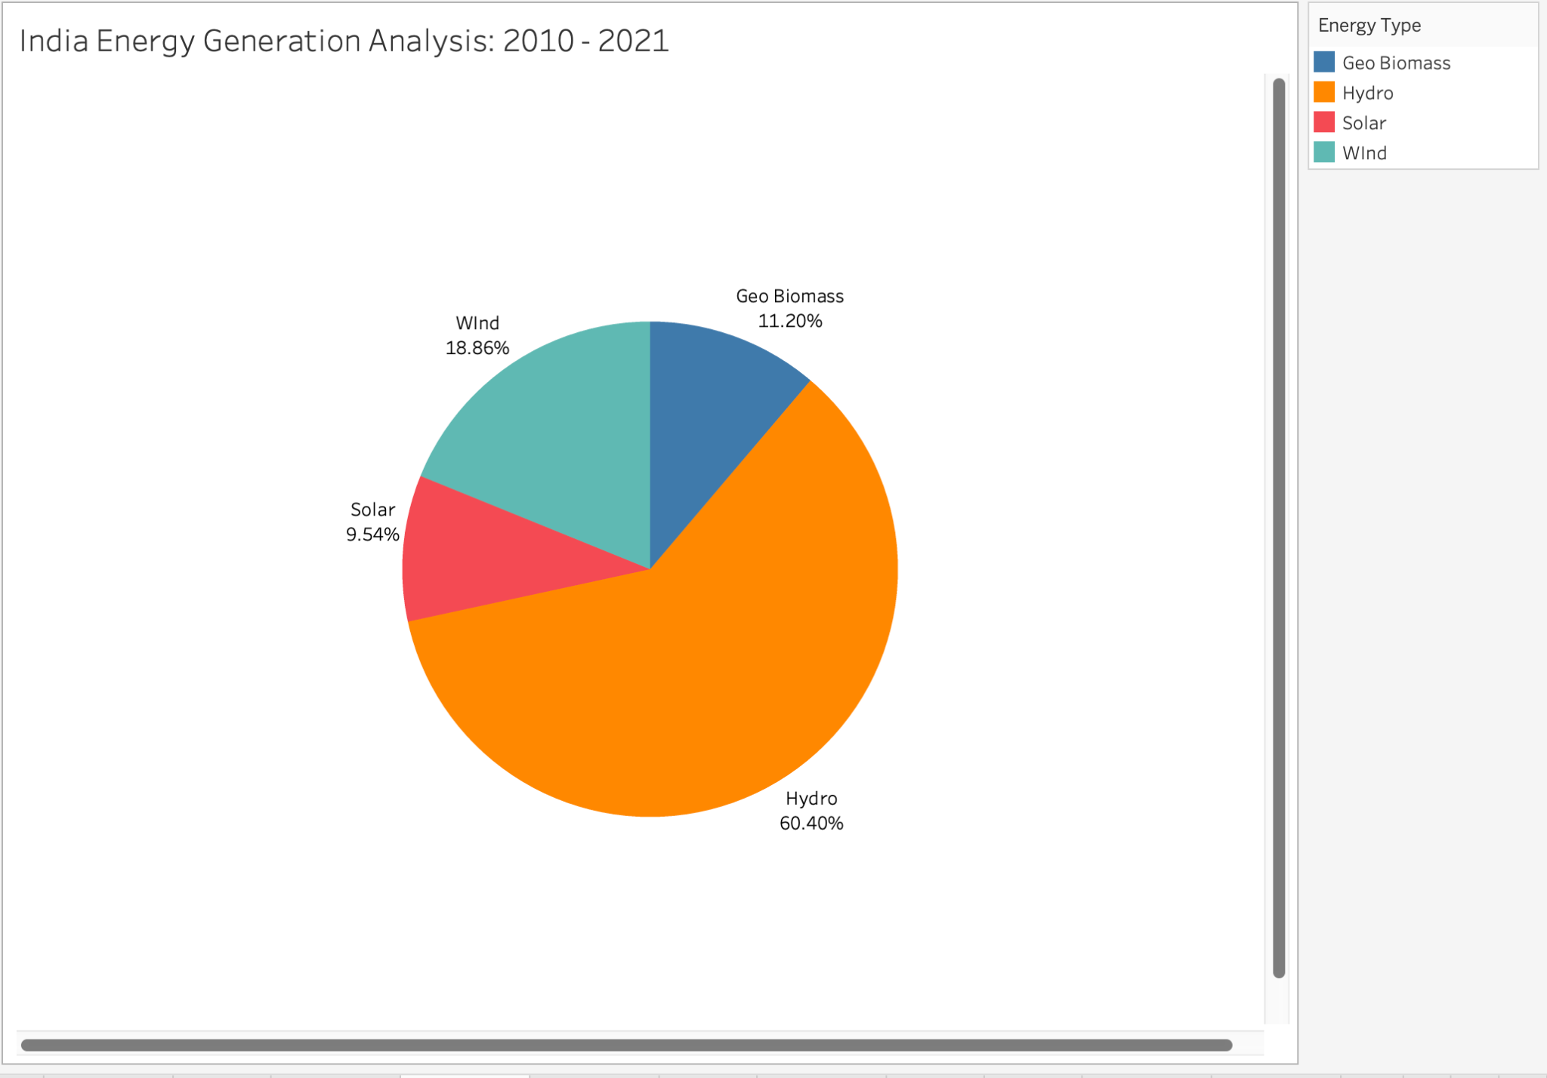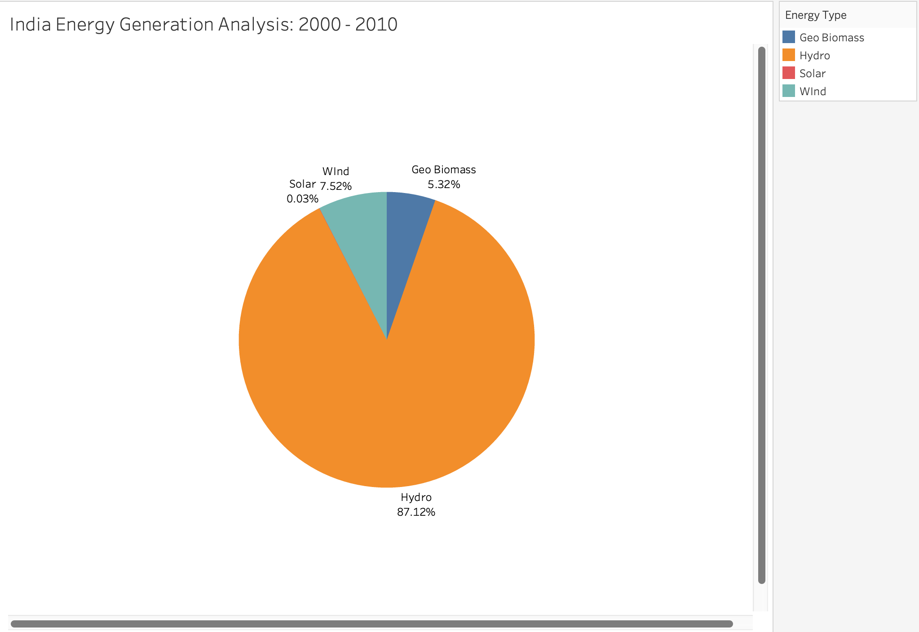

The share of solar energy has gone up from 0.03% to 9.54%, i.e., an increase of 317% overall. The dependency on hydropower energy has gone down and India is utilizing solar, wind energy and biomass energy to fulfill its energy demands.

### c. Total Renewable Energy Generation: Top 10 Countries (Since 2000):

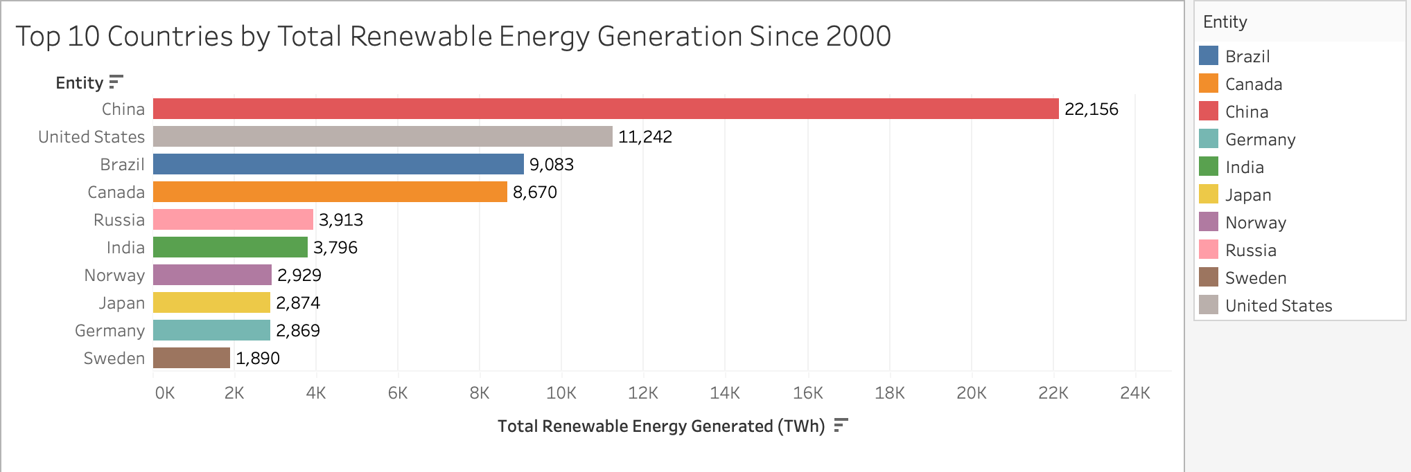

The above visualization shows the top ten countries in terms of total renewable energy generated in this century. China has generated a total of around 22.1K TWh of Renewable Energy, which is approximately double that of the second highest generating country (USA). This is due to their massive investments in infrastructure and technology, high population demands, as well as government policies.

India stands at 6th position among all countries in the world in terms of renewable energy generation, with around 3.8K Twh of energy.

### d. Total Renewable Energy Generation: India vs Neighbours (Since 2000):

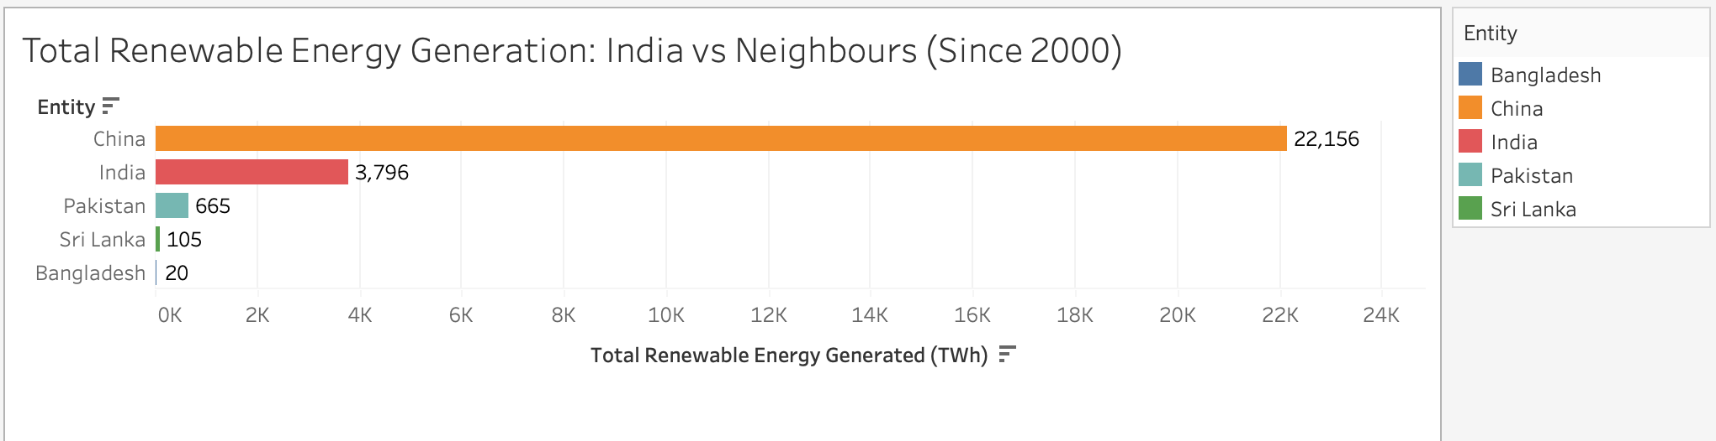

While India may lag behind China in renewable energy generation, it still stands out as a significant player in the global renewable energy landscape, especially when compared to its neighboring countries. Despite China's considerable lead, with 17 times more energy generation than India, our nation has made notable strides in renewable energy deployment. This positions India as a noteworthy contributor to the global shift towards sustainable energy sources.

## 3. Electricity Generation From Renewables

Dataset used : [share-electricity-renewables.csv](https://www.kaggle.com/datasets/belayethossainds/renewable-energy-world-wide-19652022/data?select=04+share-electricity-renewables.csv)

The Dataset contains the following columns:

* **Entity:** Contains 104 different regions (countries, continents, income brackets)
* **Code:** Contains region codes.
* **Year:** In the range 1965 - 2021
* **Electricity from Wind (%):** Represents wind energy electricity generation
* **Electricity from Hydro (%):** Represents hydroelectric energy electricity generation
* **Electricity from Solar (%):** Represents solar energy electricity generation.
* **Other Renewables (%):** Includes electricity generation from bioenergy and other renewable energy sources.

### a. Electricity From Renewables Share:

This visualization presents a world map illustrating the average percentage of electricity generated from renewables across different countries. Each country is color-coded based on its average percentage share in the total energy mix. Dark green is used to show larger values while yellow-green shows lower values.

Iceland, Norway and Brazil stand out with the highest share, while some countries in Africa and middle-eastern Asia have significantly lesser percentages. India stands close to China with a less than average percentage, marked by light green color.

### 

### b. Percentage of Electricity From Renewables - World vs India:

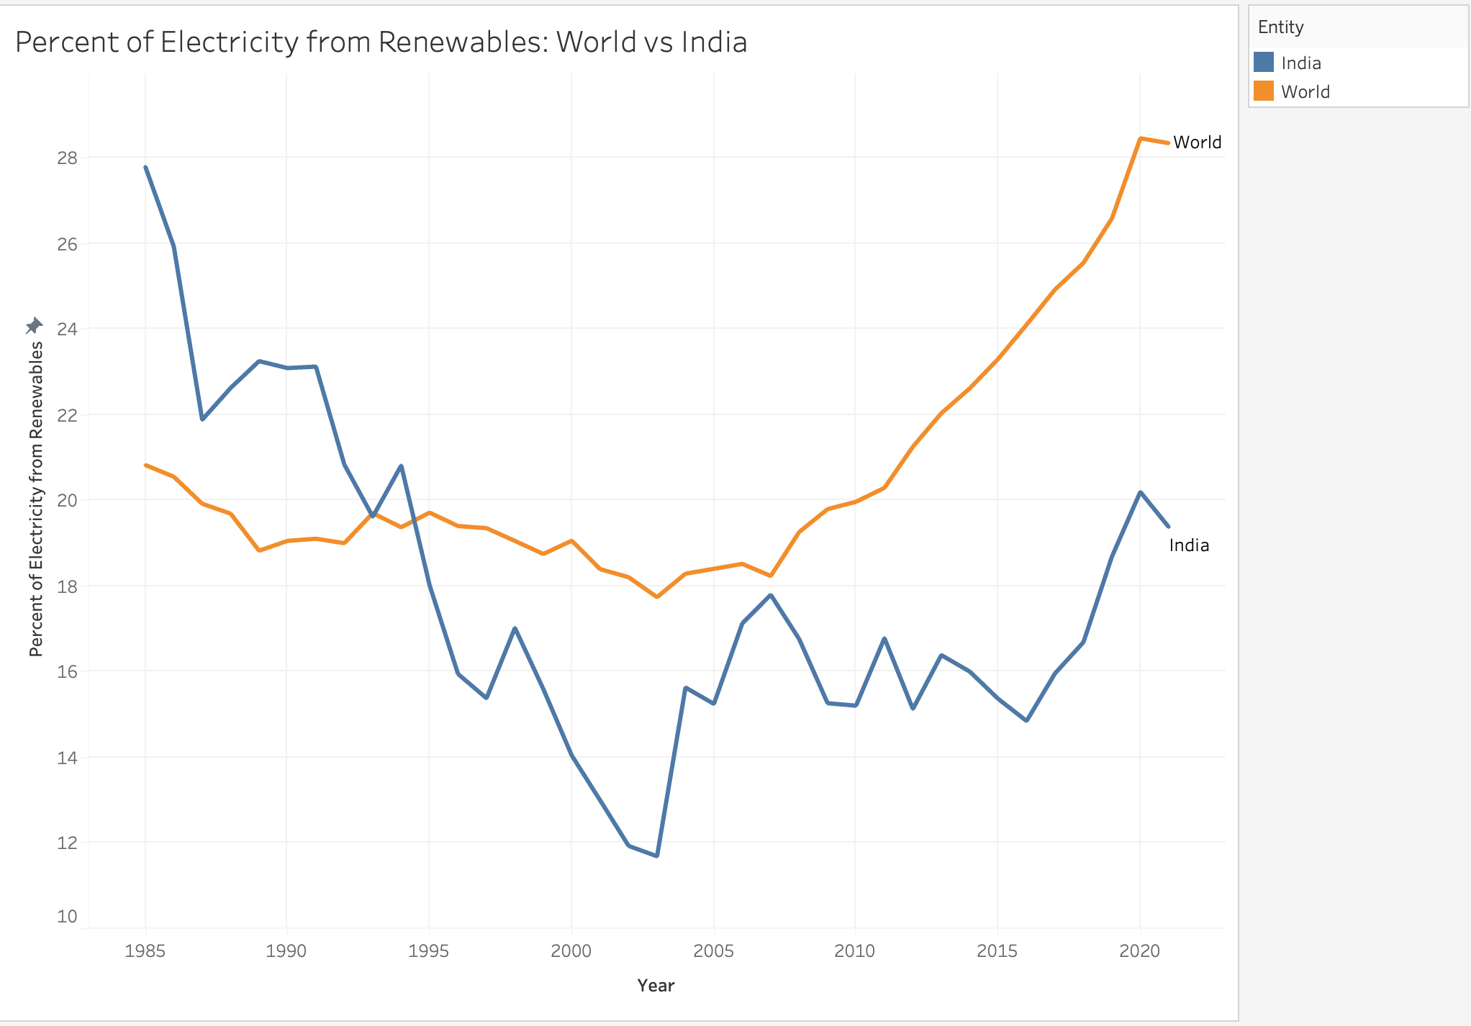

When compared with global trends, India's trajectory in electricity generation from renewable sources reveals a notable shift over time. Initially, during the 1980s, India stood as an above-average generator of electricity from renewables. However, by around the mid-1990s, there was a discernible decline, resulting in a comparatively lower generation. This transformation highlights India's evolving position in the renewable energy landscape, indicating fluctuations in its relative contribution to the global renewable energy mix.

### c. Percentage of Electricity From Renewables in 2021 - Top 10 Countries:

### 

Among all countries, the top ten nations with the highest proportion of electricity sourced from renewables comprise Nepal, Lesotho, Central African Republic, Bhutan, Iceland, Ethiopia, Paraguay, Democratic Republic of Congo, Norway and Costa Rica. These countries boast exceptionally high percentages, exceeding 95%, attributed to their abundant natural resources and supportive government policies. Whether nestled amid the Himalayas like Bhutan and Nepal, endowed with vast river systems like Paraguay and Congo, or graced with geothermal hotspots like Iceland, each country possesses a unique natural endowment that lends itself to renewable energy exploitation. Moreover, the proactive implementation of supportive government policies and incentives has significantly contributed to the widespread adoption of renewable energy technologies in these nations.

### d. Percentage of Electricity From Renewables in 2021- India vs Top 5 GDPs:

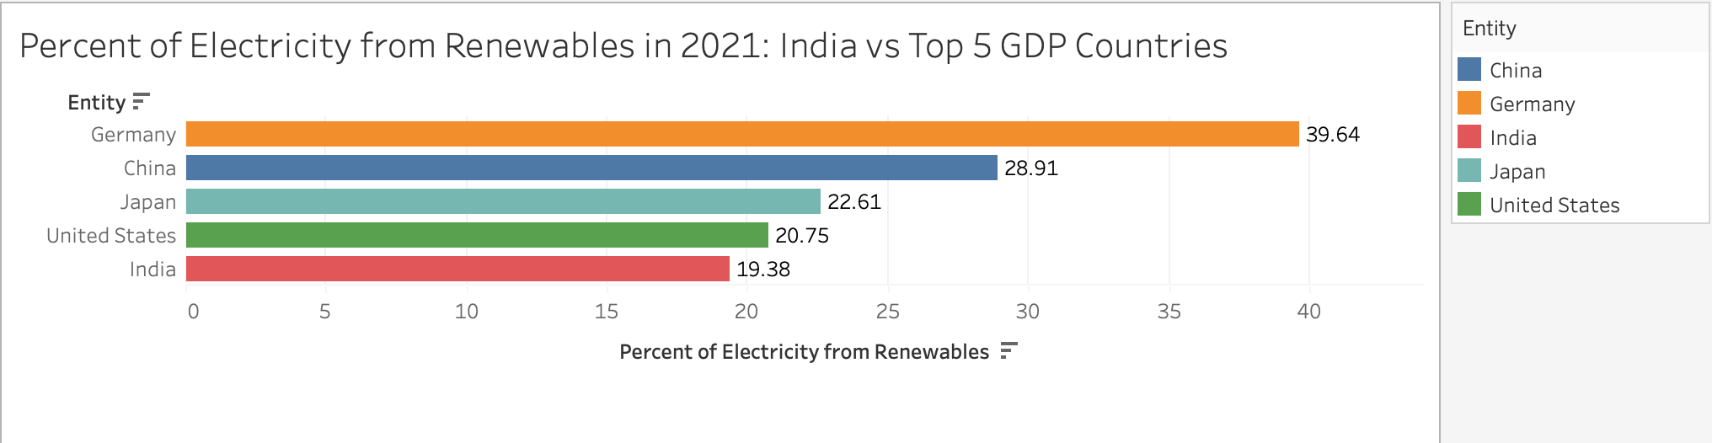

This bar chart compares the top 5 GDP countries in the world in 2021, showing that China and India are in the lead as compared to developed countries like Japan, Germany and USA.

### e. Percentage of Electricity From Renewables - India vs Neighboring Countries:

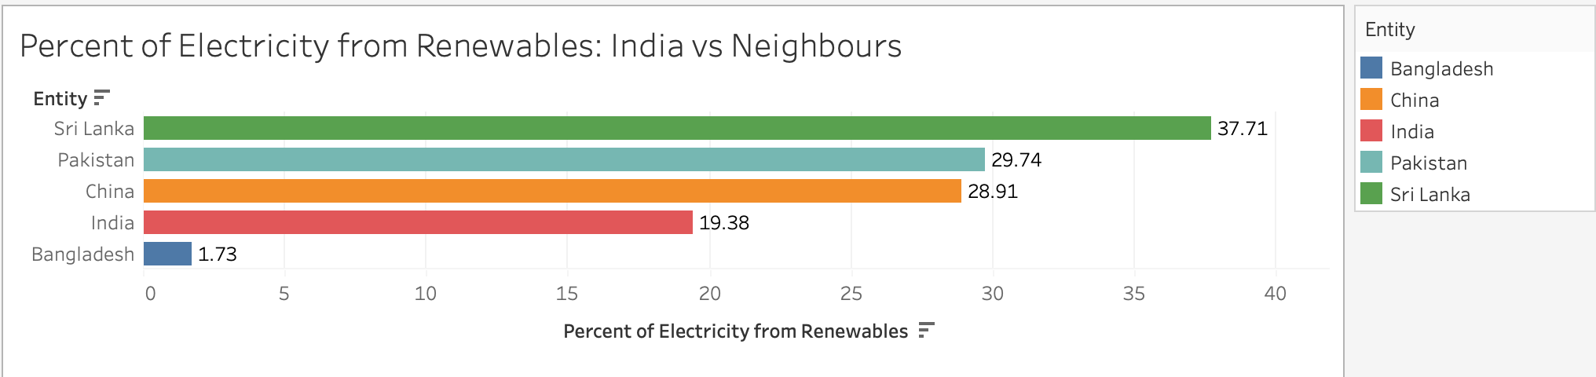

When compared to its neighbors, India's performance in terms of the percentage of electricity generated from renewables trails behind notably, especially when compared to Sri Lanka and Pakistan. Despite sharing geographical proximity and facing similar environmental challenges, India lags behind its neighbors in harnessing renewable energy sources to power its electricity grid. This discrepancy underscores the need for India to intensify its efforts and bolster its renewable energy initiatives to catch up with its regional counterparts and fulfill its commitments towards sustainable energy development.

### f. Percentage of Electricity From Renewables - By Income Brackets (2000 - 2021):

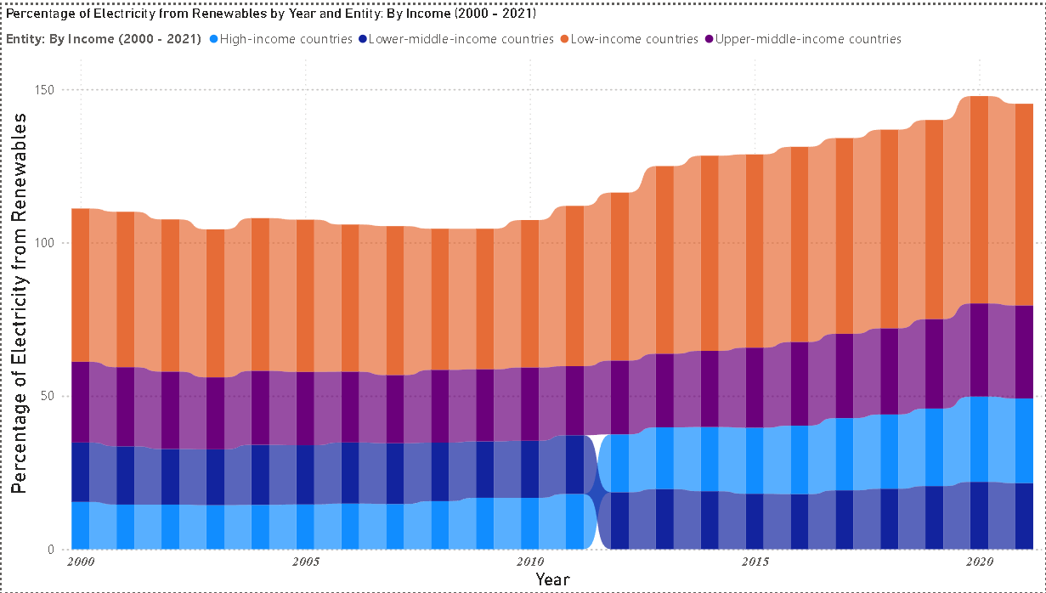

The ribbon chart illustrates the evolution of the percentage of electricity generated from renewables across different income brackets from 2000 to 2021. Notably, low-income countries emerge as leaders in this transition, consistently showcasing the highest percentages and demonstrating a steady upward trajectory over the years. Conversely, high-income countries initially lagged behind, but a significant turning point occurred around 2011 when they surpassed lower-middle-income countries in renewable energy adoption.

### g. Percentage Improvement of Electricity From Renewables (2010 - 2021) - Top 10 and Bottom 10 Countries:

### 

The horizontal bar chart depicts the percent improvement in renewable electricity usage from 2010 to 2021 for top and bottom-performing countries. Luxembourg, Liberia, and the Falkland Islands emerge as top performers with significant improvements, showcasing effective policies and investments in renewable energy infrastructure. Conversely, countries such as Ghana, Congo, and Burundi show negative trends, indicating a decrease in the use of renewable electricity sources.

### h. Percentage Improvement of Electricity From Renewables (2010 - 2021) - India vs Select Countries:

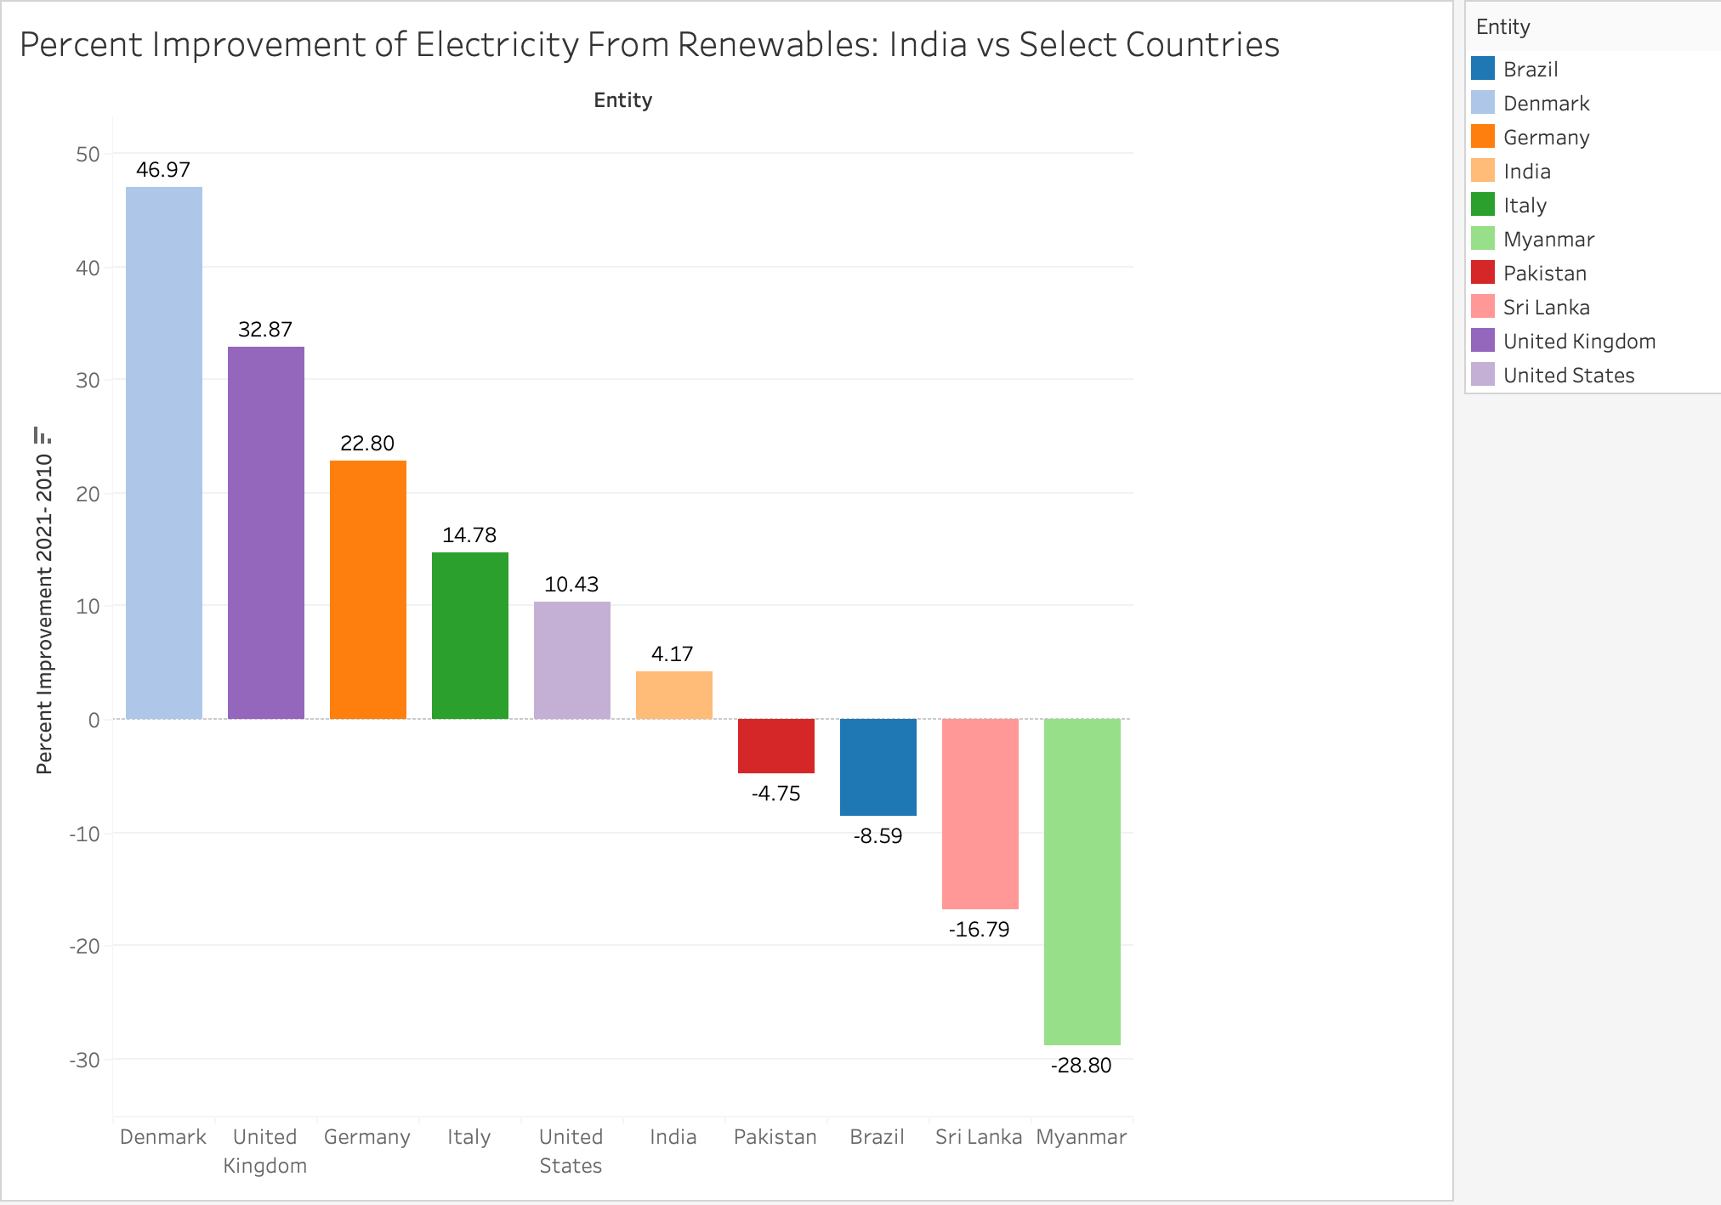

The bar graph presents the percent improvement in electricity generation from renewable sources from 2010 to 2021 for India compared to several other countries. India shows a slight increase in renewable energy improvement of 4.17%, marked by a small positive value, contrasting sharply with countries like Denmark (46.97%) and the United Kingdom (32.87%), which exhibit substantial positive gains. The graph highlights the varied progress across nations in enhancing their renewable energy capabilities, with India lagging behind some of its global counterparts. However, it also emphasizes India's relative advancement compared to neighboring countries such as Pakistan (-4.75%), Sri Lanka (-16.79%), and Myanmar (-28.80%), which exhibit substantial negative improvements.

## 4. Hydropower Energy

Datasets used : [05 hydropower-consumption.csv](https://www.kaggle.com/datasets/belayethossainds/renewable-energy-world-wide-19652022/data?select=05+hydropower-consumption.csv) and [06 hydro-share-energy.csv](https://www.kaggle.com/datasets/belayethossainds/renewable-energy-world-wide-19652022/data?select=06+hydro-share-energy.csv)

The Dataset contains the following columns:

* **Entity:** Contains 104 different regions (countries, continents, income brackets)
* **Code:** Contains region codes.
* **Year:** In the range 1965 - 2021
* **Electricity from hydro (TWh):** The amount of electricity produced from hydroelectric sources
* **Hydro (% equivalent primary energy):** Measures the percentage of hydroelectric energy within a nation's overall energy composition.

### a. World Hydro Electricity Generation

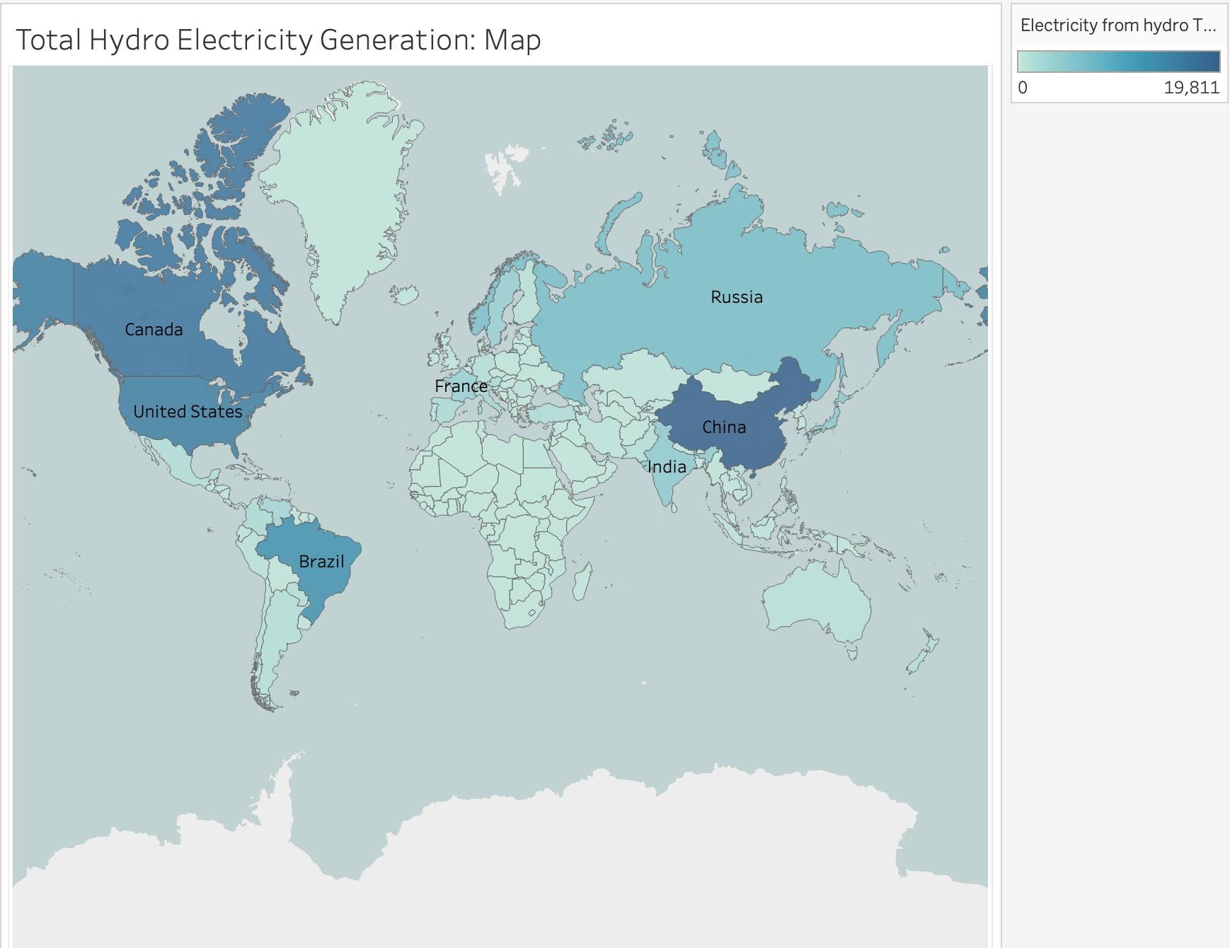

This visualization presents a world map illustrating the total hydroelectricity generated across different countries. Each country is color-coded using different hues of blue based on its percentage share of renewable energy in the total energy mix, with dark blue showing high values and light blue showing lower values.

We can infer from the map that China, Canada, USA and Brazil generate significantly high amounts of hydroelectricity. Conversely, India's hydroelectric output appears relatively average when compared to the global scale, reflecting its utilization of hydroelectric potential but also highlighting potential for further development in this sector. Meanwhile, nations in Africa and Australia exhibit notably lower levels of hydroelectricity generation. This disparity can be attributed to various factors, including geographical constraints, limited access to water resources suitable for hydropower, and differing national priorities in energy development.

### b. World Hydro Electricity Generation - By Decades

### 

The line chart presented here illustrates the global trend in hydropower electricity generation, utilizing data spanning several decades.The observed pattern of an approximately linear increase in hydropower generation since the 1960s underscores the longstanding role of hydropower as a significant contributor to the global energy mix. This steady growth trajectory reflects the continuous investment in hydropower infrastructure and the harnessing of hydroelectric potential across various regions worldwide. Notably, the period from the beginning of the 1970s to the end of the 2000s demonstrates a remarkably consistent linear trend in hydropower generation. However, a notable deviation from this linear trend has been observed since the turn of the 21st century, marked by a sharp increase in hydropower generation. If you look into the numbers, they say that there’s been an increase of 34.5%.

### c. Total Hydro Electricity Generation - By Continents

When comparing the total hydroelectricity generation by continents, it becomes evident that Asia emerges as the primary contributor, accounting for a substantial 28.34% of the global share. Countries like China, India, and Russia play pivotal roles in driving Asia's hydroelectric output, leveraging their extensive river networks and hydroelectric dams to meet growing energy demands sustainably.

Africa has a very low percentage due to water scarcity, inadequate infrastructure, and competing priorities for development investment. Similarly, Australia's arid climate and relatively lower population density limit the feasibility of large-scale hydroelectric projects.

### d. Total Hydro Electricity Generation - Top 10 Countries (since 2010)

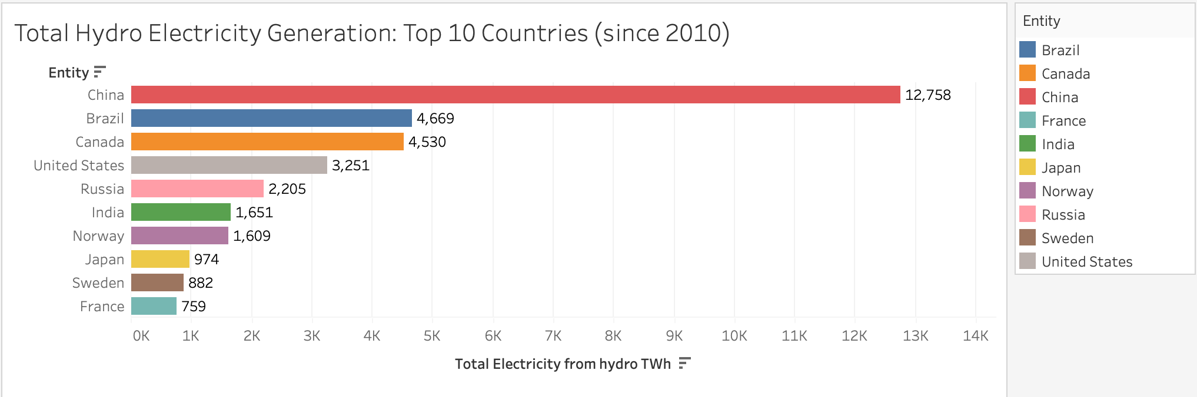

As we observed in the previous visualizations, Asia generates the most hydro electricity and evidently China has the highest contribution of 12,758 TWh of hydro electricity. Other Asian countries such as Russia, India and Japan also contribute to its massive generation, with India having generated 1,651 TWh of hydro electricity since 2010.

### e. Total Hydro Electricity Generation - Comparison with India

China's hydroelectric generation has witnessed a notable and consistent upsurge over the years, reflecting the nation's strategic focus on renewable energy development. In contrast, countries such as India, the USA, the UK, Germany, and Japan have exhibited relatively stable levels of hydroelectric generation since the mid-1960s.

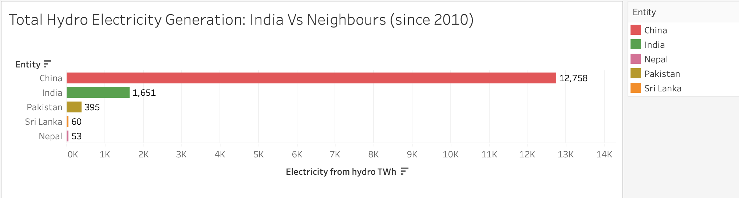

When juxtaposed with its neighboring countries, excluding China, India demonstrates commendable performance in hydroelectricity generation. Despite this achievement, India still lags significantly behind China in terms of hydroelectric output. However, when considering its regional context, India's hydroelectric endeavors stand out, reflecting substantial investments and advancements in renewable energy infrastructure.

### f. Total Hydro Electricity Generation - Comparison of the last two decades of select countries

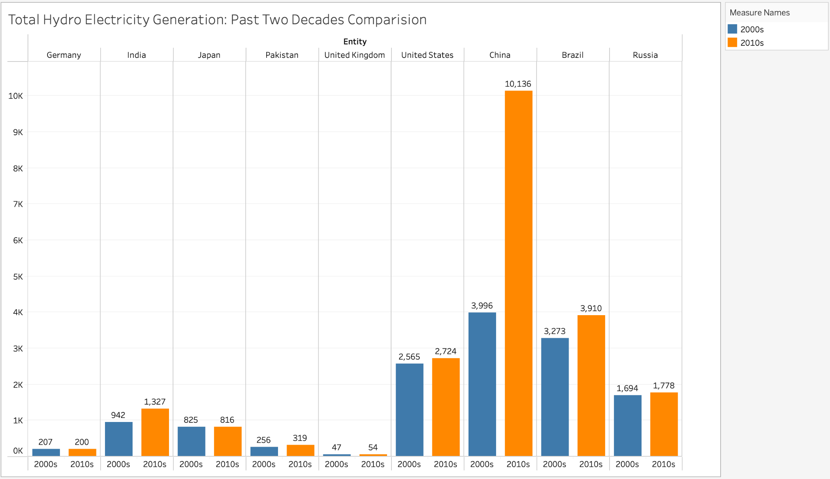

The depicted side-by-side bar chart provides a comparative analysis of hydroelectricity generation between the 2000s and 2010s across multiple countries, offering valuable insights into the influence of recent technological advancements on this growth. Notably, India demonstrates a modest increase of 385 TWh in hydroelectricity generation during the 2010s compared to the preceding decade. Conversely, countries like Germany, Japan, the UK, the USA, and Russia exhibit minimal changes in their hydroelectric output. In stark contrast, China stands out with a substantial overall increase of 6140 TWh, underscoring the significant impact of technological advancements and infrastructure development on hydroelectric expansion within the region.

### g. Hydro Energy Share in Total Energy in 2021:

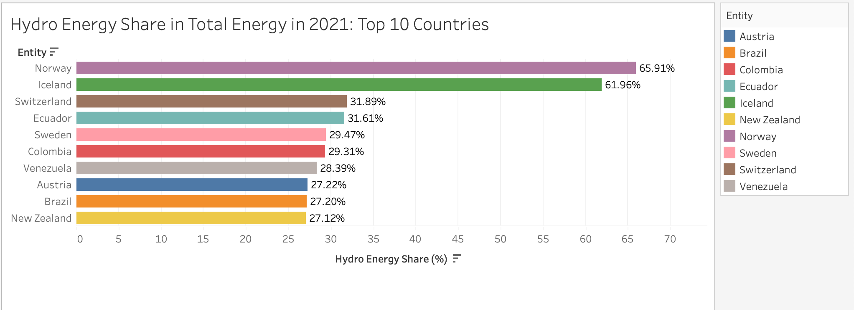

This horizontal bar graph visualizes the percentage share of hydro energy in the total energy consumption for the top 10 countries in this category for the year 2021. The term 'Hydro Energy Share' refers to the percentage of hydro energy utilized within the total energy consumption of a country. Norway leads as the top performer with the highest hydro energy share in total energy consumption, reaching 65.91%, showcasing the nation's substantial dependence on hydroelectric power. Following closely behind is Iceland, with a share of 61.96%. An intriguing observation is the significant drop in the share of the third-ranking country, Switzerland, which stands at merely half of Iceland's share, registering at 31.89%. This shows how far and ahead Norway and Iceland are as compared to the rest of the world in their reliance on Hydro Energy. All the other countries fall within a similar range with their hydro energy shares closely clustered together.

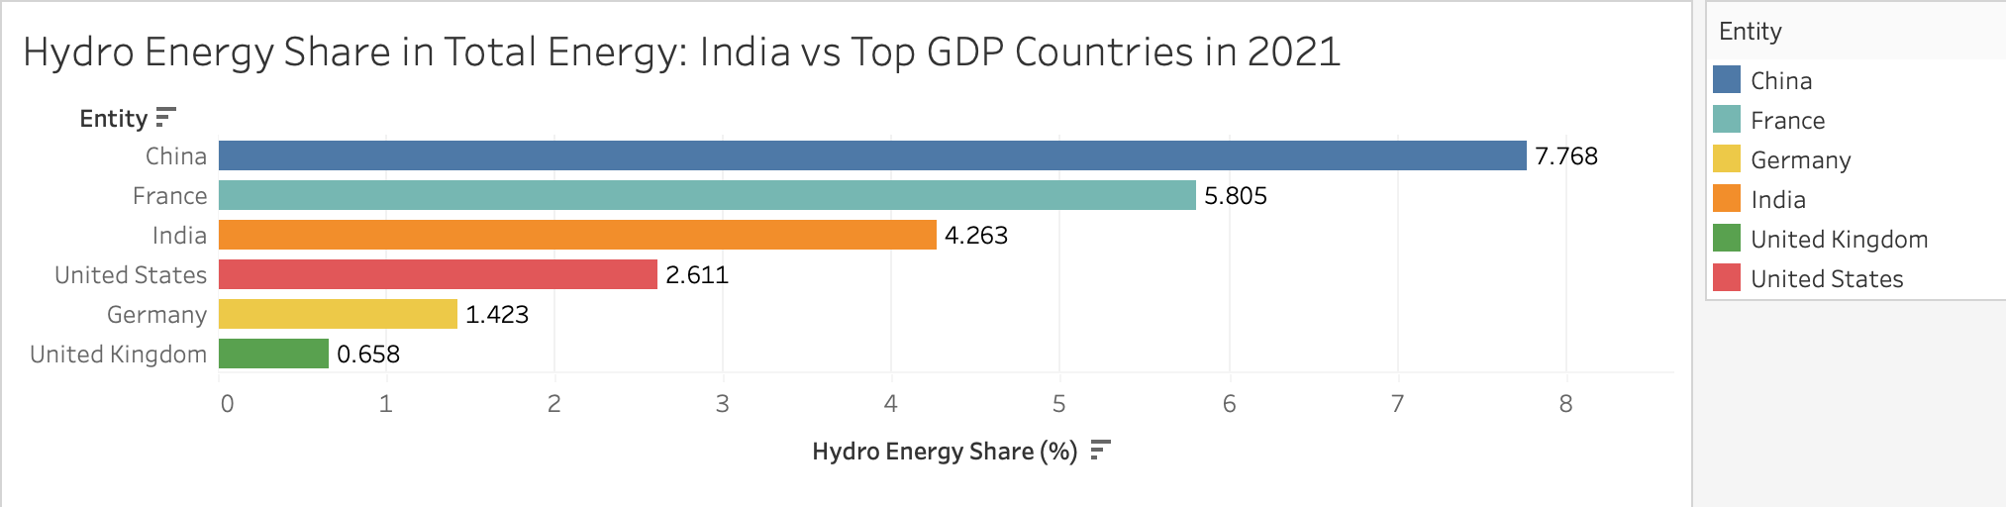

This bar graph compares the percentage share of hydro energy in the total energy consumption for India and several top GDP countries in the year 2021.The comparison enables us to assess India's position relative to top GDP countries in terms of hydro energy adoption, providing insights into the country's renewable energy landscape.China leads among the displayed countries with the highest hydro energy share at 7.768%, followed by France at 5.805% and India at 4.263%. The United States, Germany, and the United Kingdom have lower share of hydro energy as compared to India. While China and France lead in hydro energy share, India's respectable share underscores its efforts towards diversifying its energy sources and promoting renewable energy adoption.

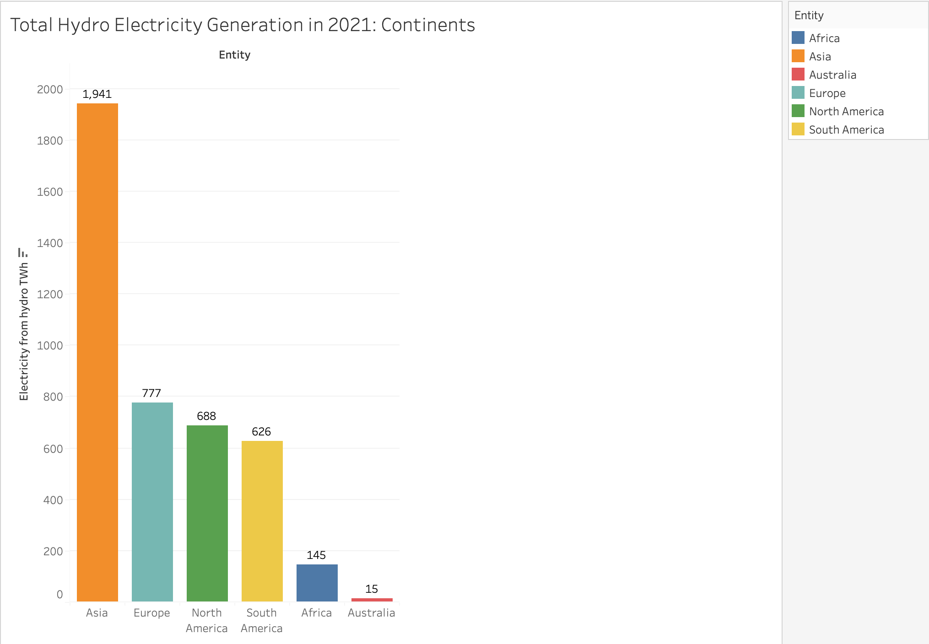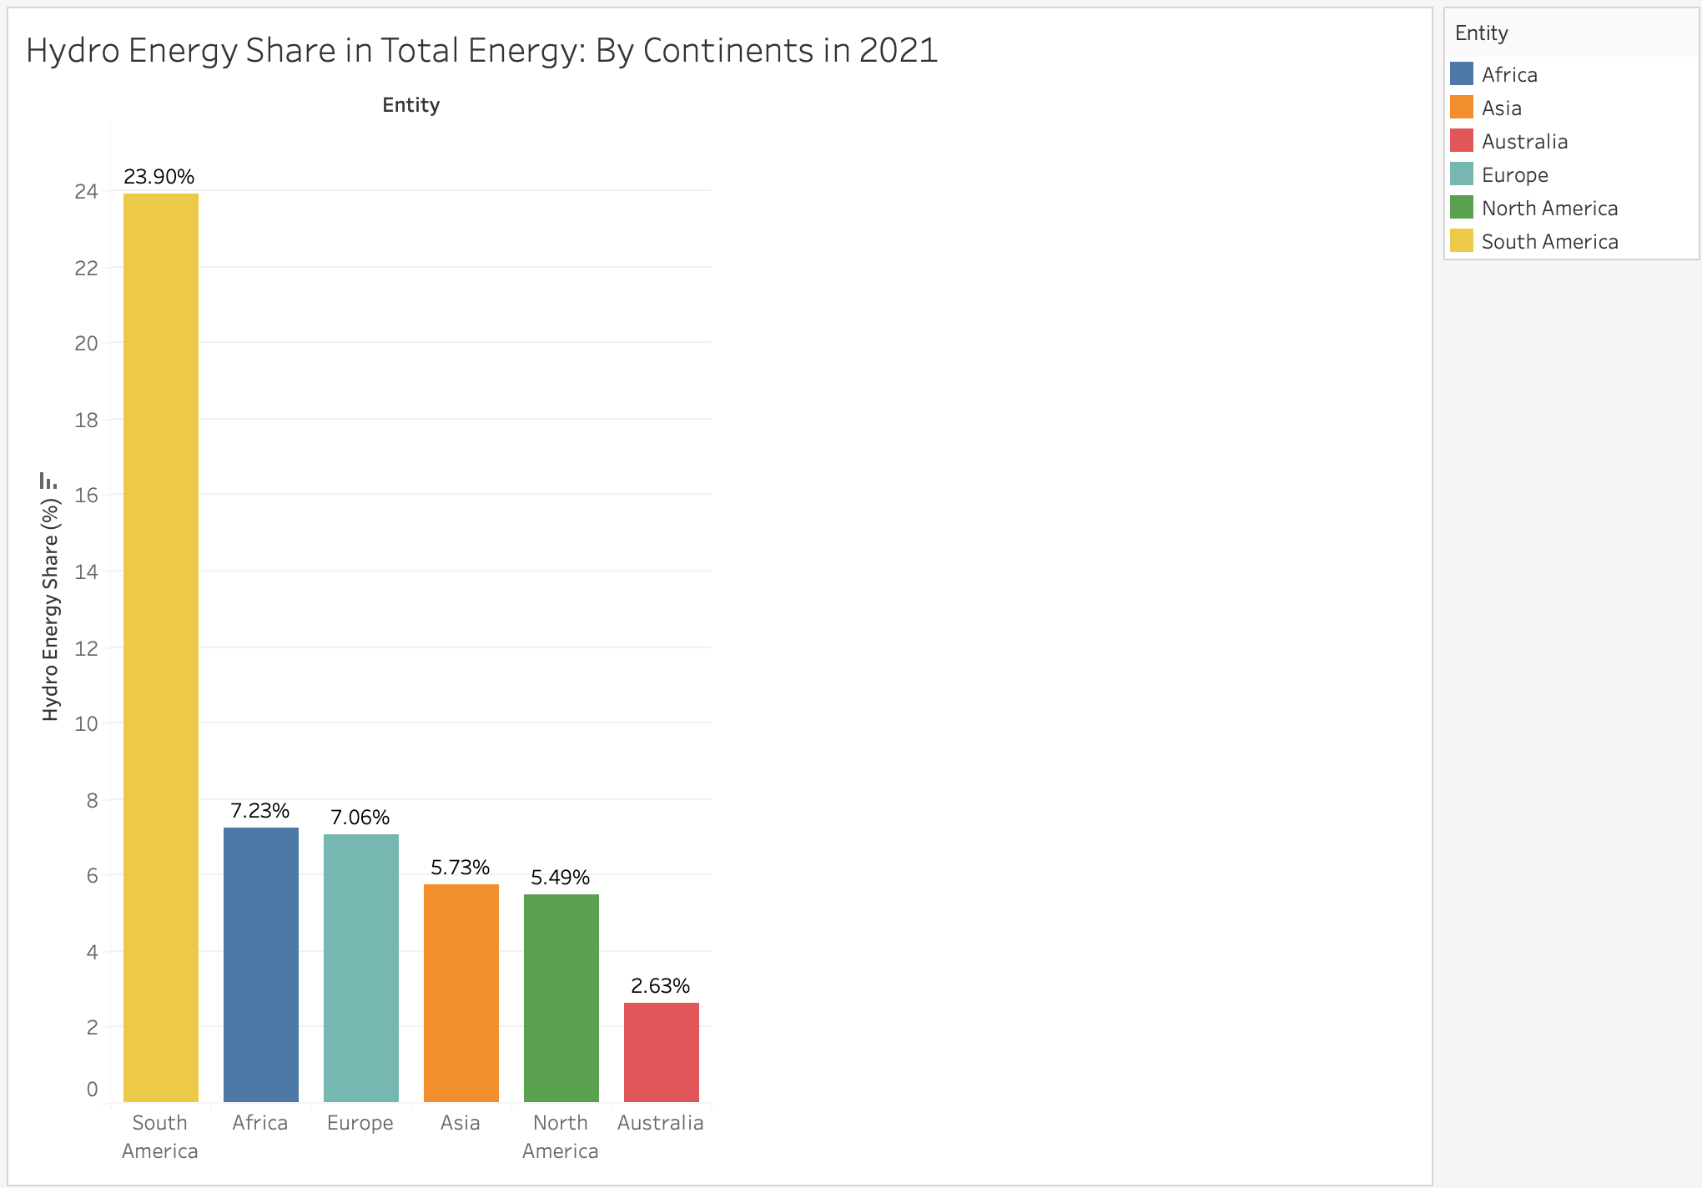

The side-by-side comparison of total hydroelectricity generation and the share of hydroelectricity in the total energy mix across continents for 2021 reveals intriguing insights into global energy dynamics. Asia emerges as the dominant producer of hydroelectricity, leading with a substantial contribution of 1,941 TWh, followed closely by Europe and North America. However, when considering the share of hydroelectricity in the total energy mix, South America takes the lead with an impressive 23.90%, followed by Africa, Europe, and Asia.

Notably, while Asia leads in hydroelectricity generation, its share in the total energy mix is relatively lower compared to South America and Africa, indicating varying priorities and energy sourcing strategies across continents.

## 5. Wind power Energy:

Datasets used : [08 wind-generation.csv](https://www.kaggle.com/datasets/belayethossainds/renewable-energy-world-wide-19652022?select=08+wind-generation.csv), [09 cumulative-installed-wind-energy-capacity-gigawatts.csv](https://www.kaggle.com/datasets/belayethossainds/renewable-energy-world-wide-19652022?select=09+cumulative-installed-wind-energy-capacity-gigawatts.csv), [10 wind-share-energy.csv](https://www.kaggle.com/datasets/belayethossainds/renewable-energy-world-wide-19652022?select=10+wind-share-energy.csv)

The Dataset contains the following columns:

* **Entity:** Contains 104 different regions (countries, continents, income brackets)
* **Code:** Contains region codes.
* **Year:** In the range 1965 - 2021
* **Electricity from wind (TWh):** The amount of electricity produced from wind energy
* **Wind (% equivalent primary energy):** Measures the percentage of wind energy within a nation's overall energy composition.
* **Wind Capacity (GW):** Quantifies the energy potential harnessed, showcasing the evolution of wind power infrastructure and investment.

### a.World Wind Electricity Generation:

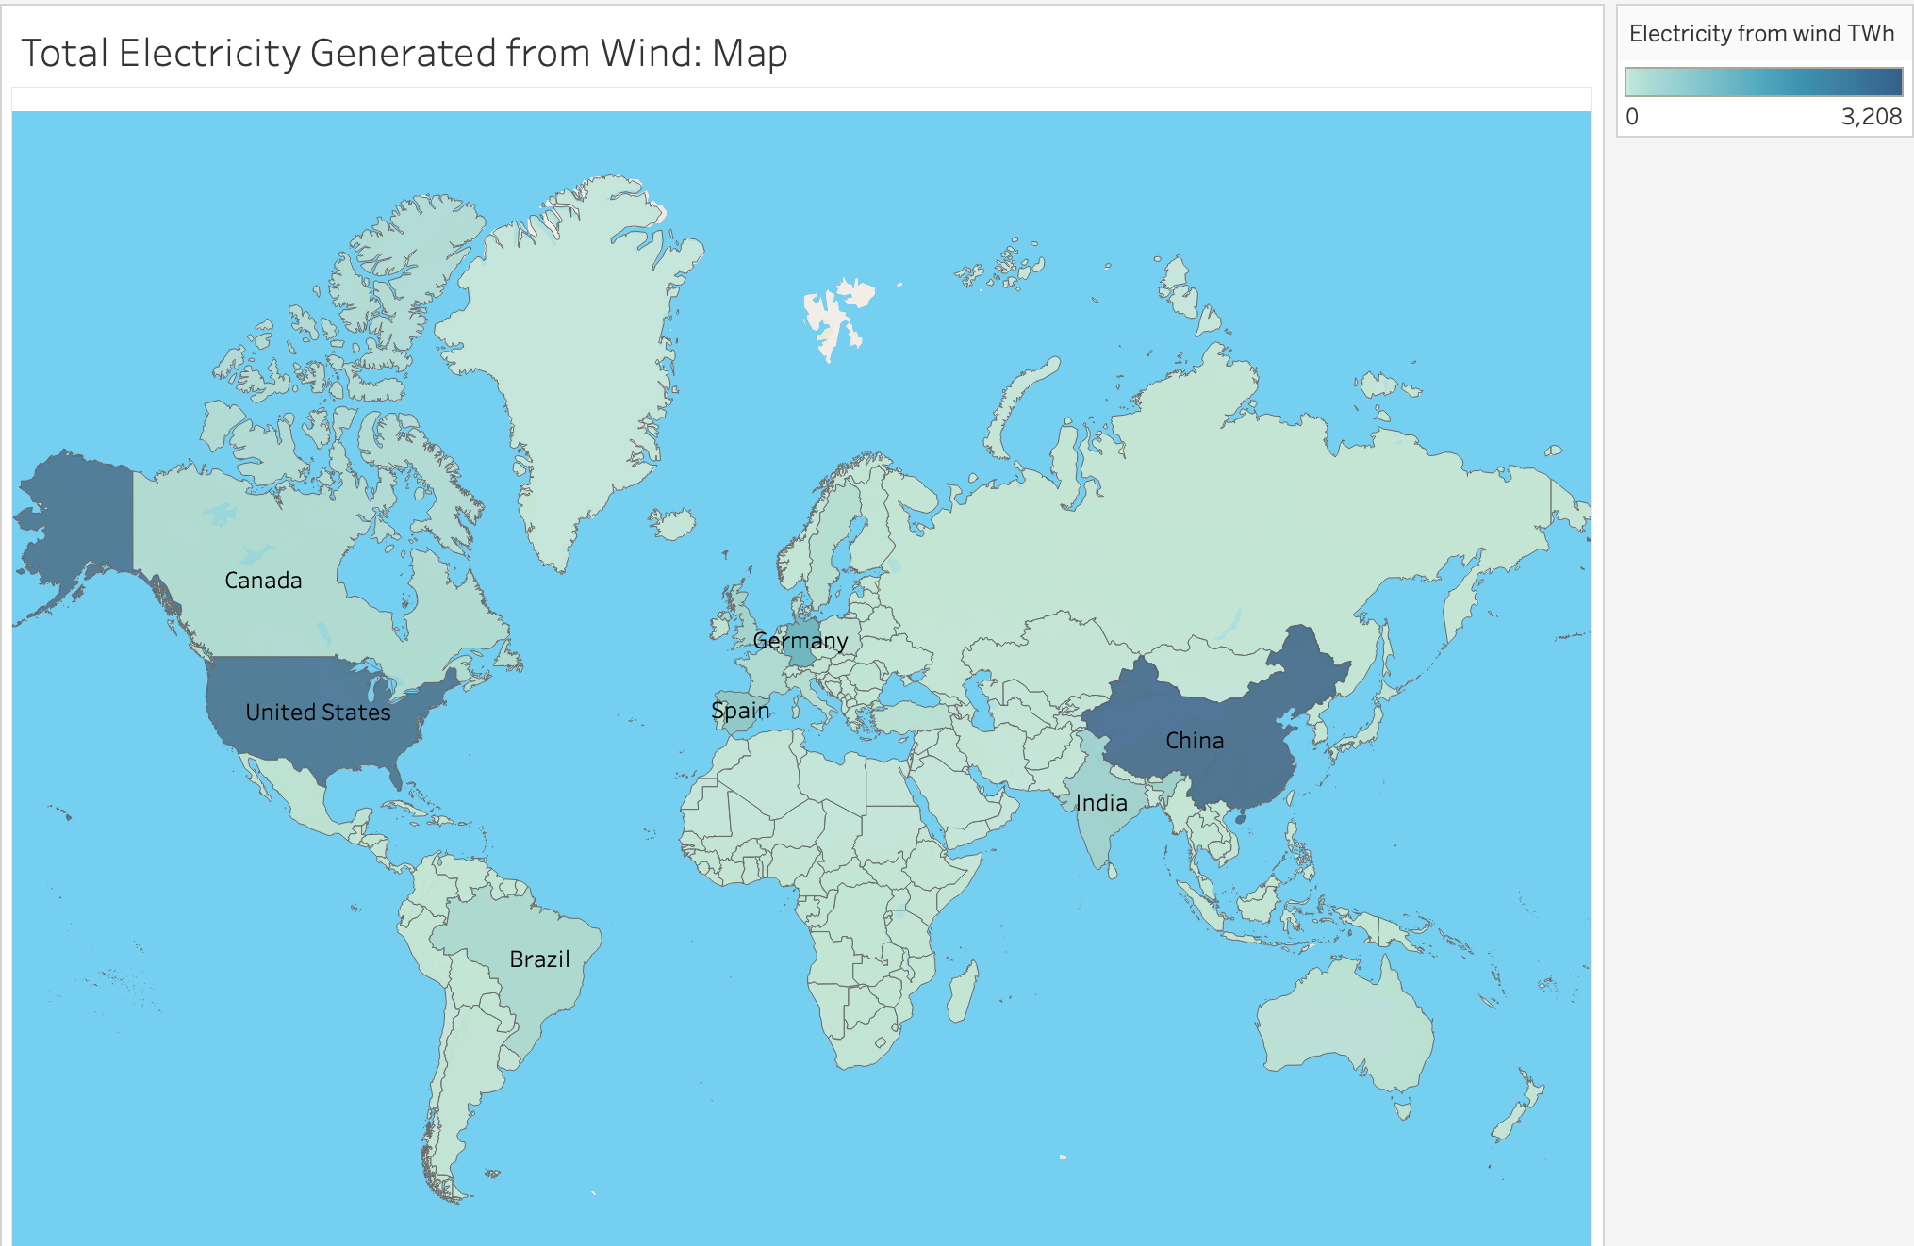

This visualization presents a world map illustrating the total electricity generated from wind across different countries. Each country is color-coded using different hues of blue based on its percentage share of renewable energy in the total energy mix, with dark blue showing high values and light blue showing lower values.

We can infer from the map that China and the USA generate significantly high amounts of wind energy. Conversely, India's wind energy output appears relatively average when compared to the global scale, reflecting its utilization of wind energy potential but also highlighting potential for further development in this sector. Meanwhile, nations in Africa and Australia exhibit notably lower levels of wind energy generation.

### b. Total Wind Electricity Generation - By Continents

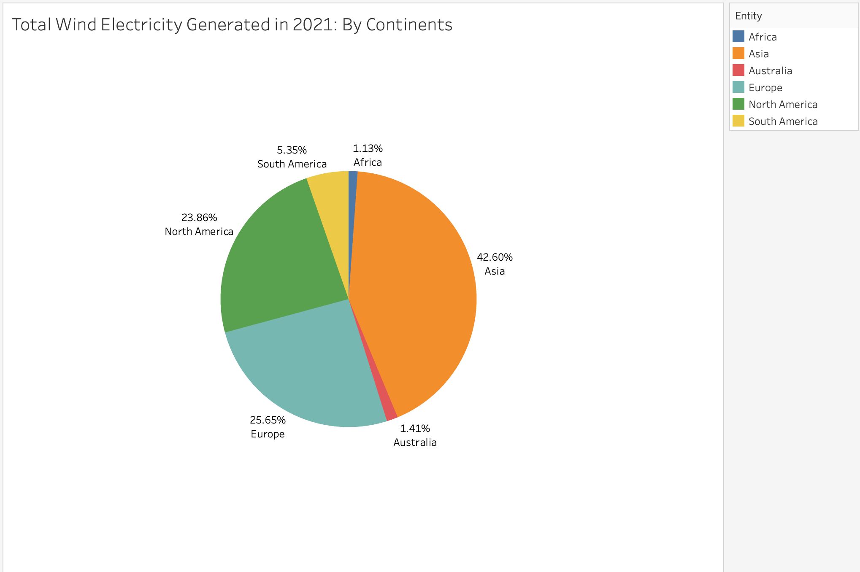

When comparing the total wind energy generation by continents, it becomes evident that Asia emerges as the primary contributor, accounting for a substantial 42.60% of the global share. Countries like China and India play pivotal roles in driving Asia's wind energy output. Satisfying the rocketing electricity demand and reducing air pollution are the main driving forces behind the development of wind energy in China. Africa has a very low percentage due to the challenges faced by African's wind energy industry policy, competition, technical and economic.

### c. Total Wind Electricity Generation - Top 10 Countries (since 2000):

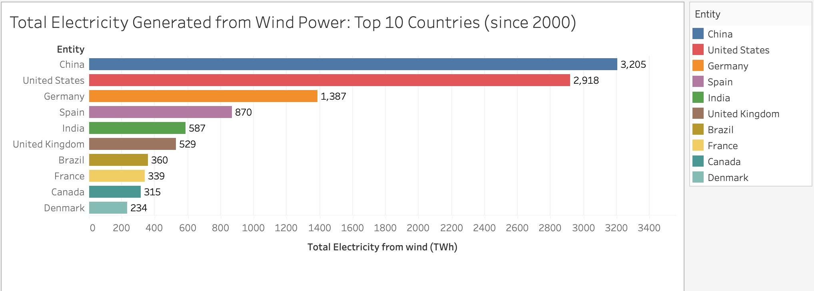

As we observed in the previous visualizations, Asia generates the most wind energy and evidently China has the highest contribution of 3,205 TWh of wind energy. India is the only other Asian country to contribute to its massive generation, with India having generated 587 TWh of wind energy since 2000.

The United States is the second biggest wind energy generator with 2,918 TWh of wind energy.

### d. Total Wind Electricity Generation - Comparison With India - Trend and Forecast:

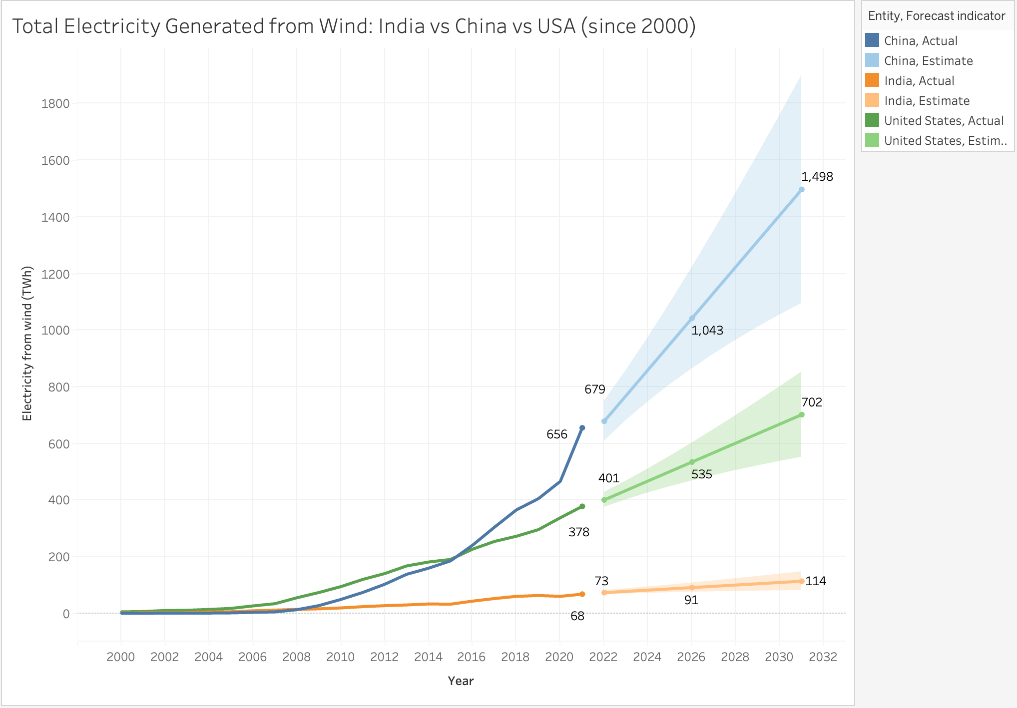

The chart offers a comparative analysis of wind energy generation between China, India, and the United States from 2000 with forecasts extending to 2032. Notably, China surpassed the United States in wind energy generation in 2015 and has led ever since. By 2026, China's wind energy output is projected to reach approximately 1,043 TWh, while India's is expected to increase to 91 TWh. By 2032, China's output is forecasted to expand further to 1,498 TWh, with India's reaching 114 TWh. This data highlights the need for India to accelerate its wind energy initiatives to keep pace with global leaders like the US and China.

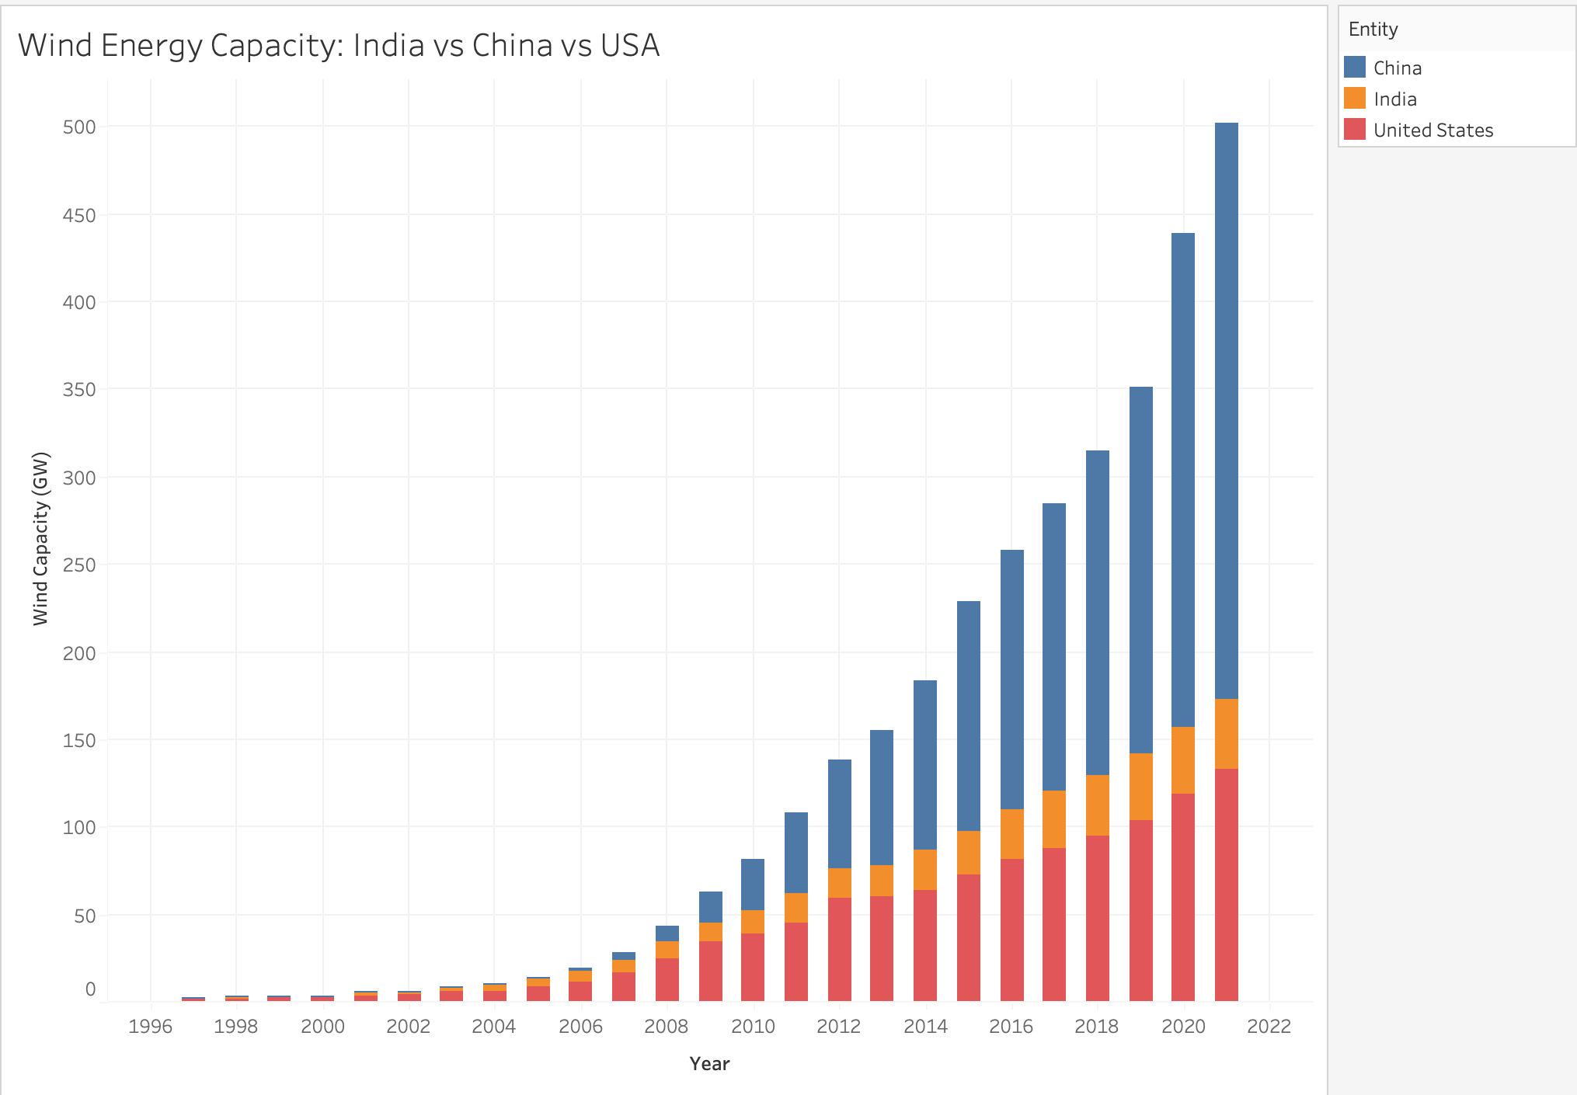

Similarly, this stacked bar graph also depicts the comparative analysis of wind energy capacity between the US, China and India.

We can note that since the year 2006, the growth of wind energy capacity has been rapid in China and the US, especially in China, while India's growth has been stable and slowly growing

### e. Total Wind Electricity Generation - Comparison of the last two decades of select countries

The depicted bar chart provides a comparative analysis of wind energy generation between the 2000s and 2010s across multiple countries, offering valuable insights into the influence of recent technological advancements on this growth.

Notably, India demonstrates a modest increase of 316 TWh in wind energy generation during the 2010s compared to the preceding decade. Countries like Germany, Spain, the UK, the USA and Brazil exhibit drastic changes in their wind energy output. In stark contrast, China stands out next to the US with a substantial overall increase of 1,971 TWh, underscoring the significant impact of technological advancements and infrastructure development on wind energy expansion within the region.

### f. Total Wind Electricity Generation - By income - Trend and Forecast:

The chart provides a comparative analysis of wind energy generation across countries categorized by income levels—high, upper-middle, lower-middle, and low.

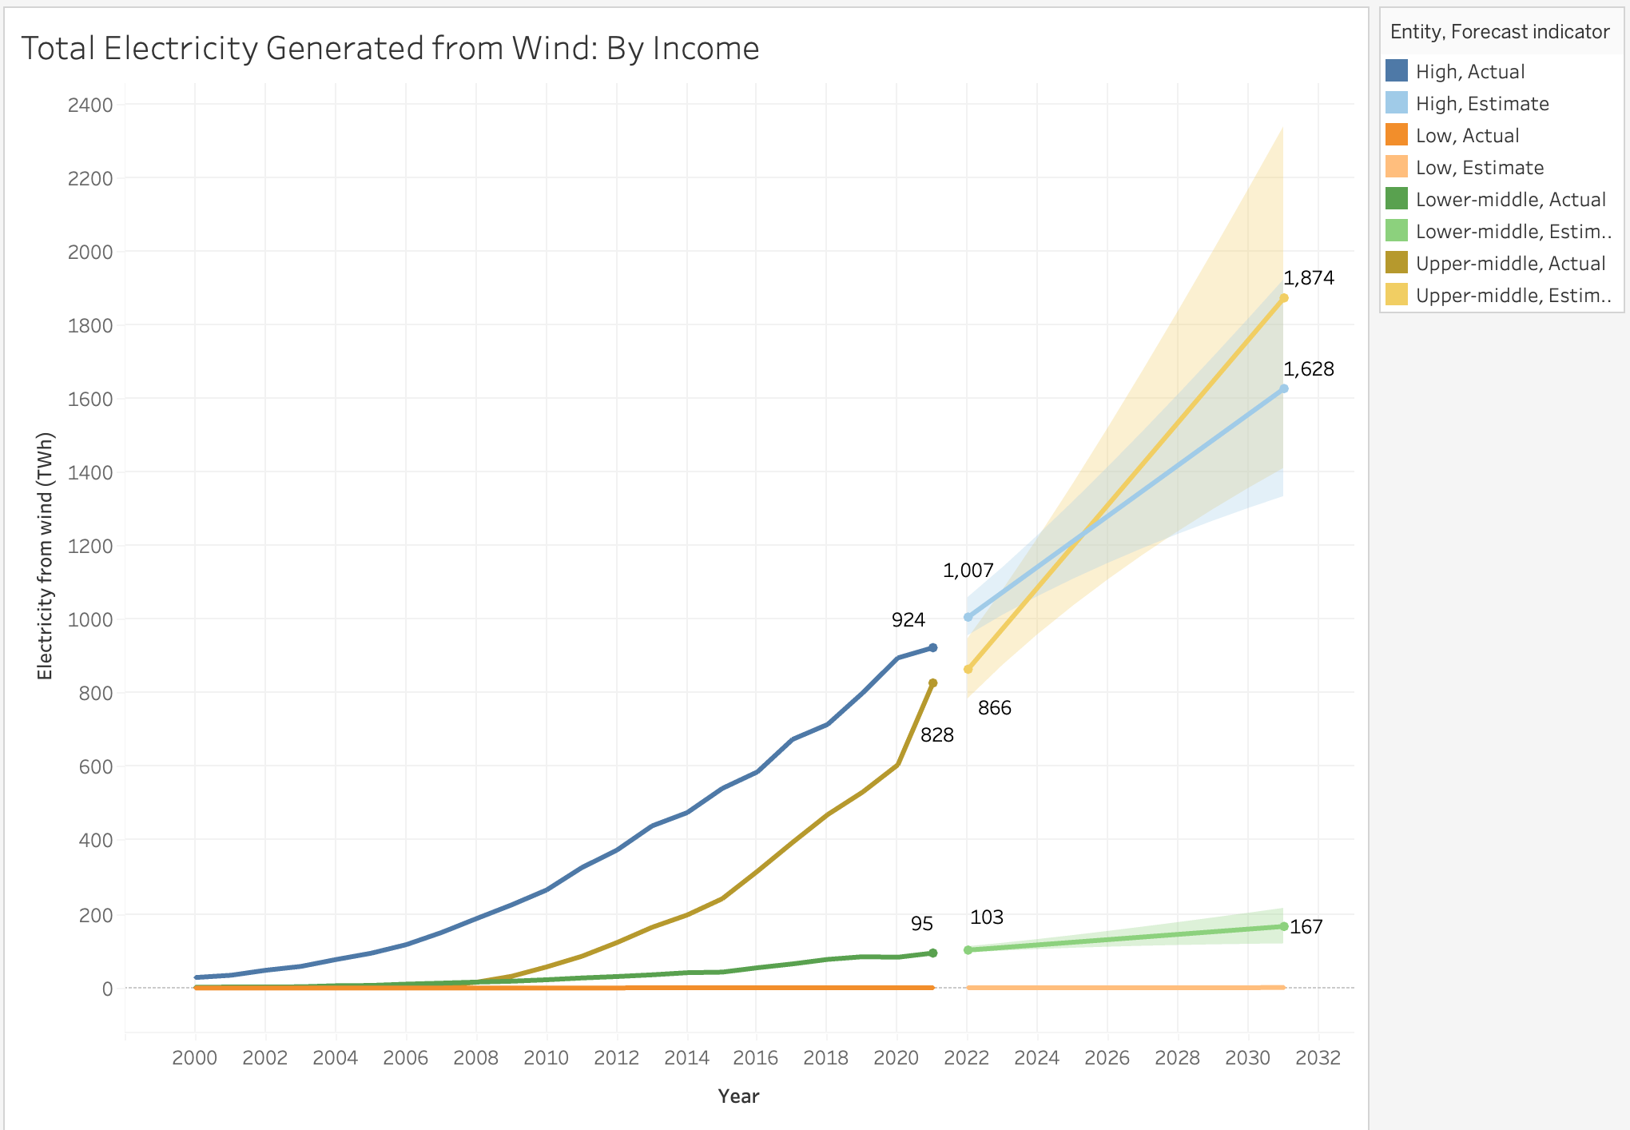

As expected, high-income countries lead in wind energy generation due to their advanced technologies and substantial investment capabilities. Upper-middle-income countries are progressively enhancing their wind energy capacities. The chart also projects wind energy generation up to the year 2032, indicating that upper-middle-income countries might surpass high-income countries by 2025, reaching an output of approximately 1,874 TWh. However, low-income countries contribute minimally to global wind energy generation, reflecting disparities in technological access and financial resources. This analysis underscores the significant impact of economic status on renewable energy development and highlights potential shifts in global energy dynamics.

### g. Total Wind Energy Capacity- By countries:

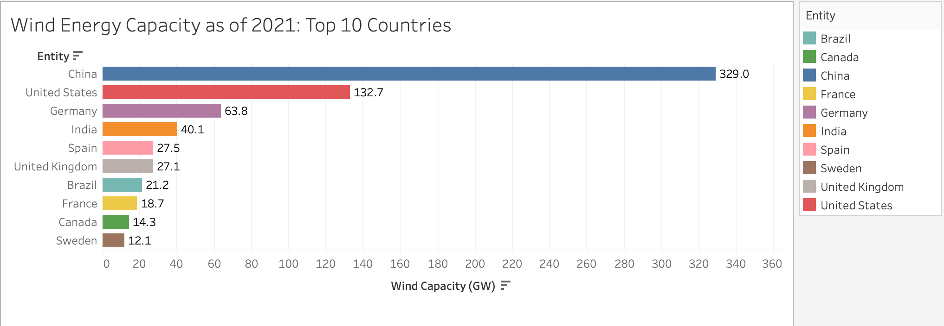

The bar chart depicting Wind Energy Capacity as of 2021 for the top 10 countries reveals a clear dominance of China in wind energy infrastructure, with a capacity of 329 GW, significantly surpassing other nations. The United States follows as a distant second with 132.7 GW, highlighting a considerable gap between the top two leaders. India holds the fourth position with a capacity of 40.1 GW, demonstrating notable progress in wind energy adoption.

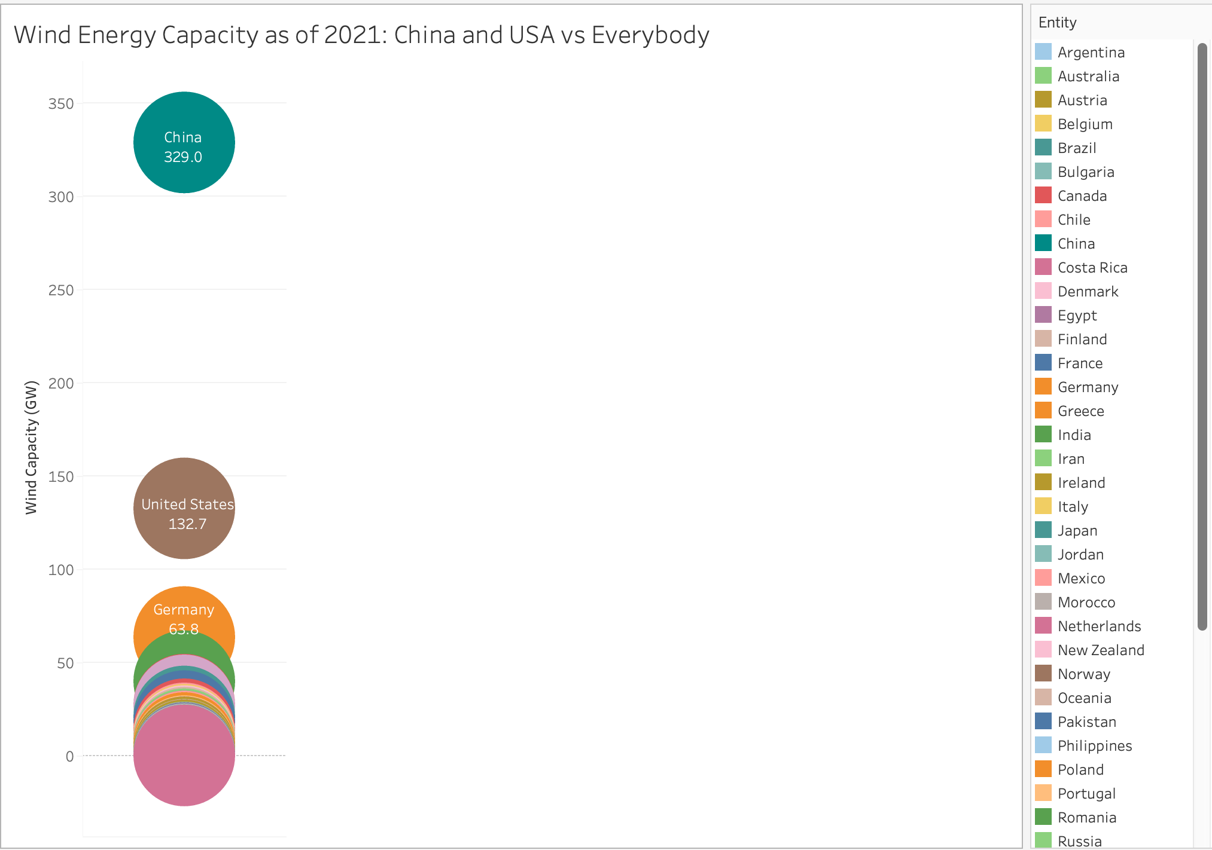

The chart vividly highlights China's dominance in wind energy capacity, significantly surpassing all other nations, including the United States, which ranks second. This visual representation underscores China's substantial investments and advancements in renewable energy, positioning it as a global leader in wind energy production.

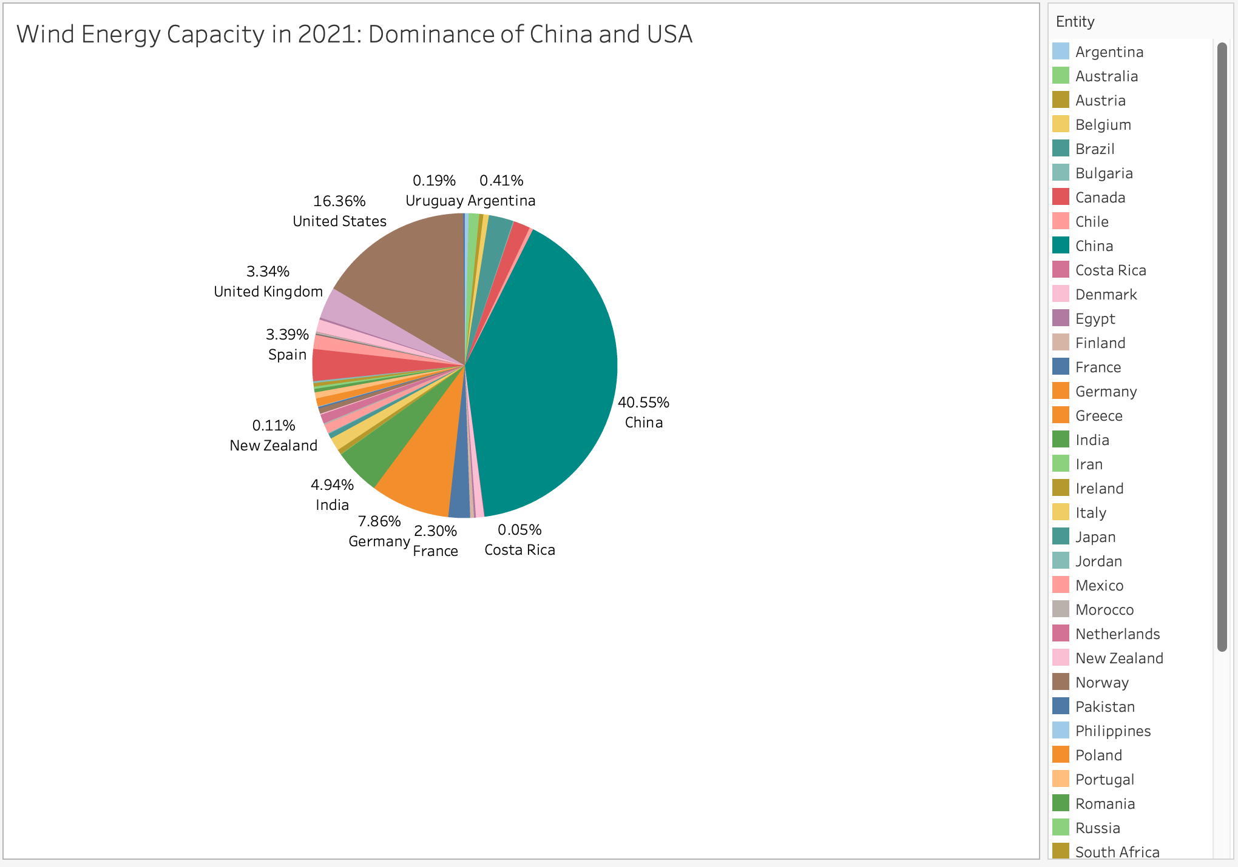

The pie chart illustrates that in 2021, China contributed 40.55% to the global wind energy capacity, marking it as a dominant player. The United States holds a significant share as well, with 16.3%. Together, these two countries account for 56.85% of the world's total wind energy capacity, underscoring their pivotal roles in the renewable energy sector.

### h. Wind Energy Share in Total Energy:

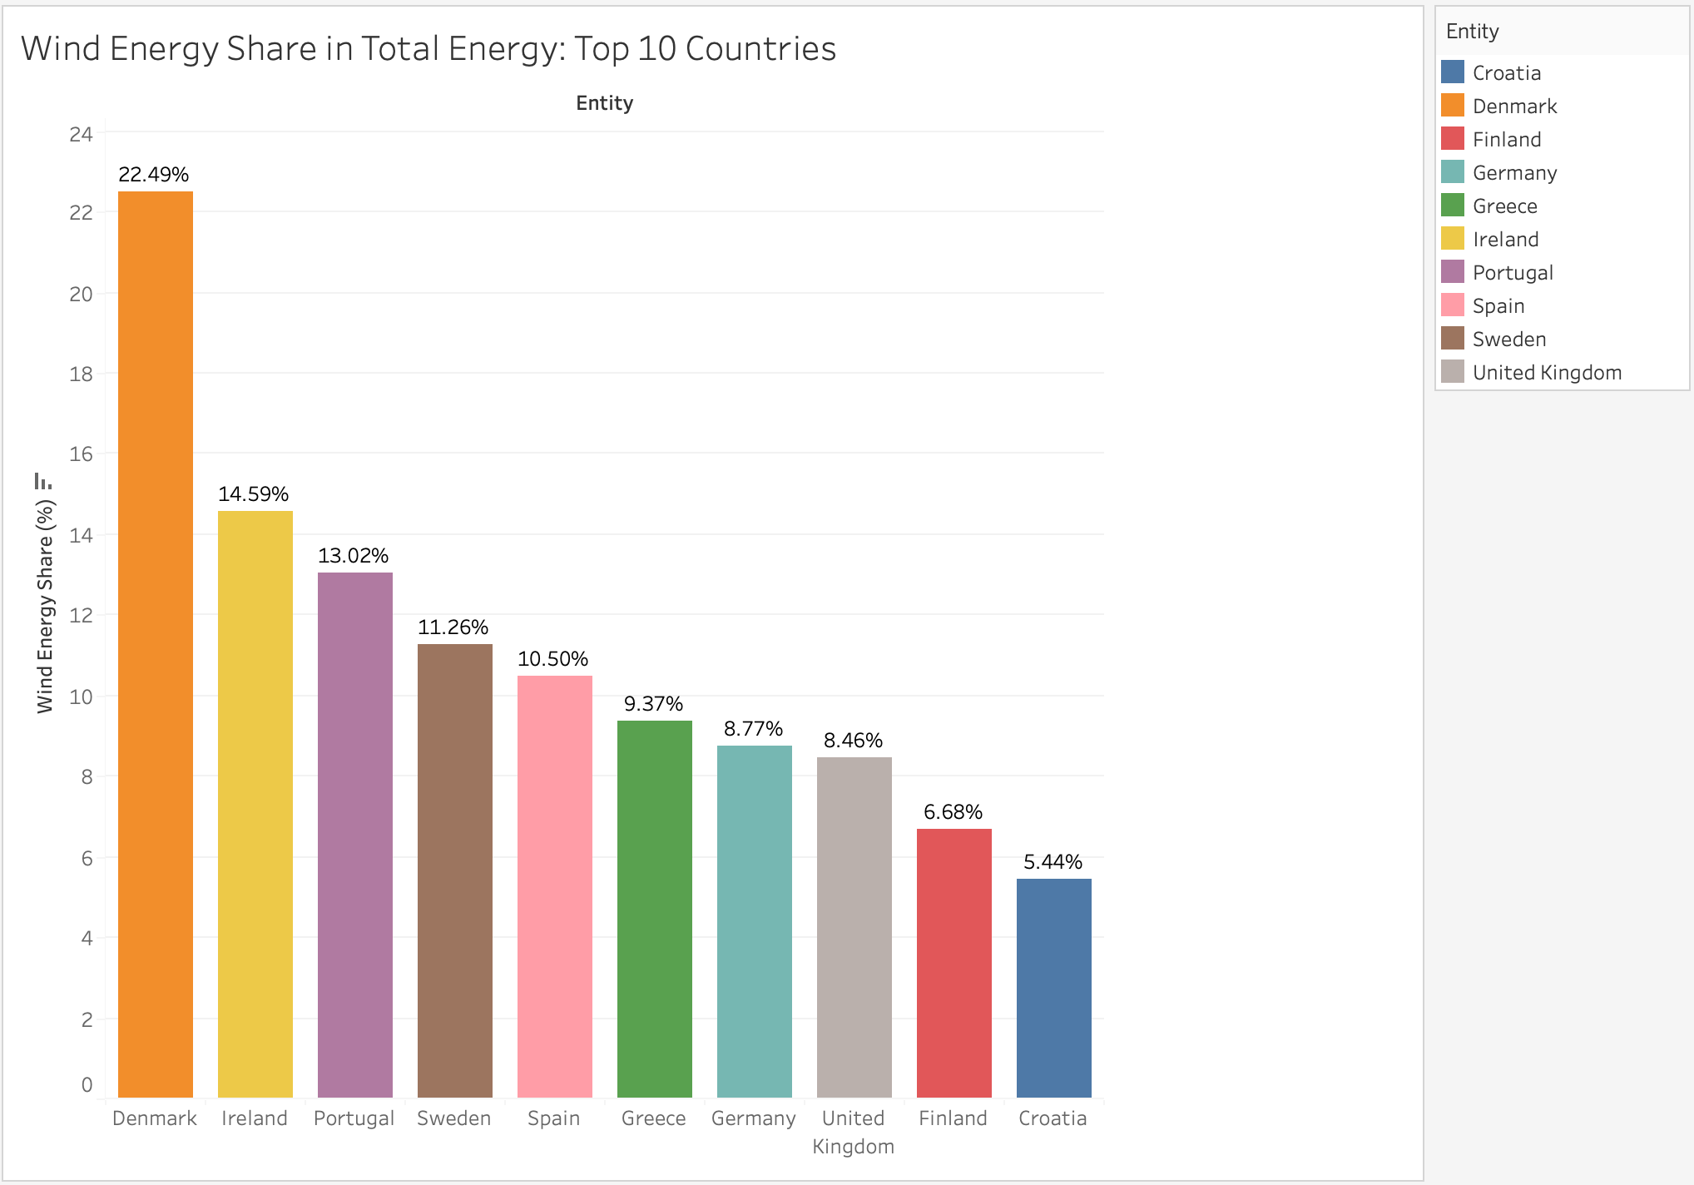

The bar chart offers a detailed comparative analysis of wind energy's contribution to the total energy mix among the top 10 countries, all located in Europe. Denmark leads impressively with 22.49% of its total energy derived from wind, followed by Ireland and Portugal. This visualization underscores the significant role wind energy plays in these countries' energy strategies, highlighting Europe's commitment to renewable energy adoption and its leadership in the global transition towards sustainable energy sources.

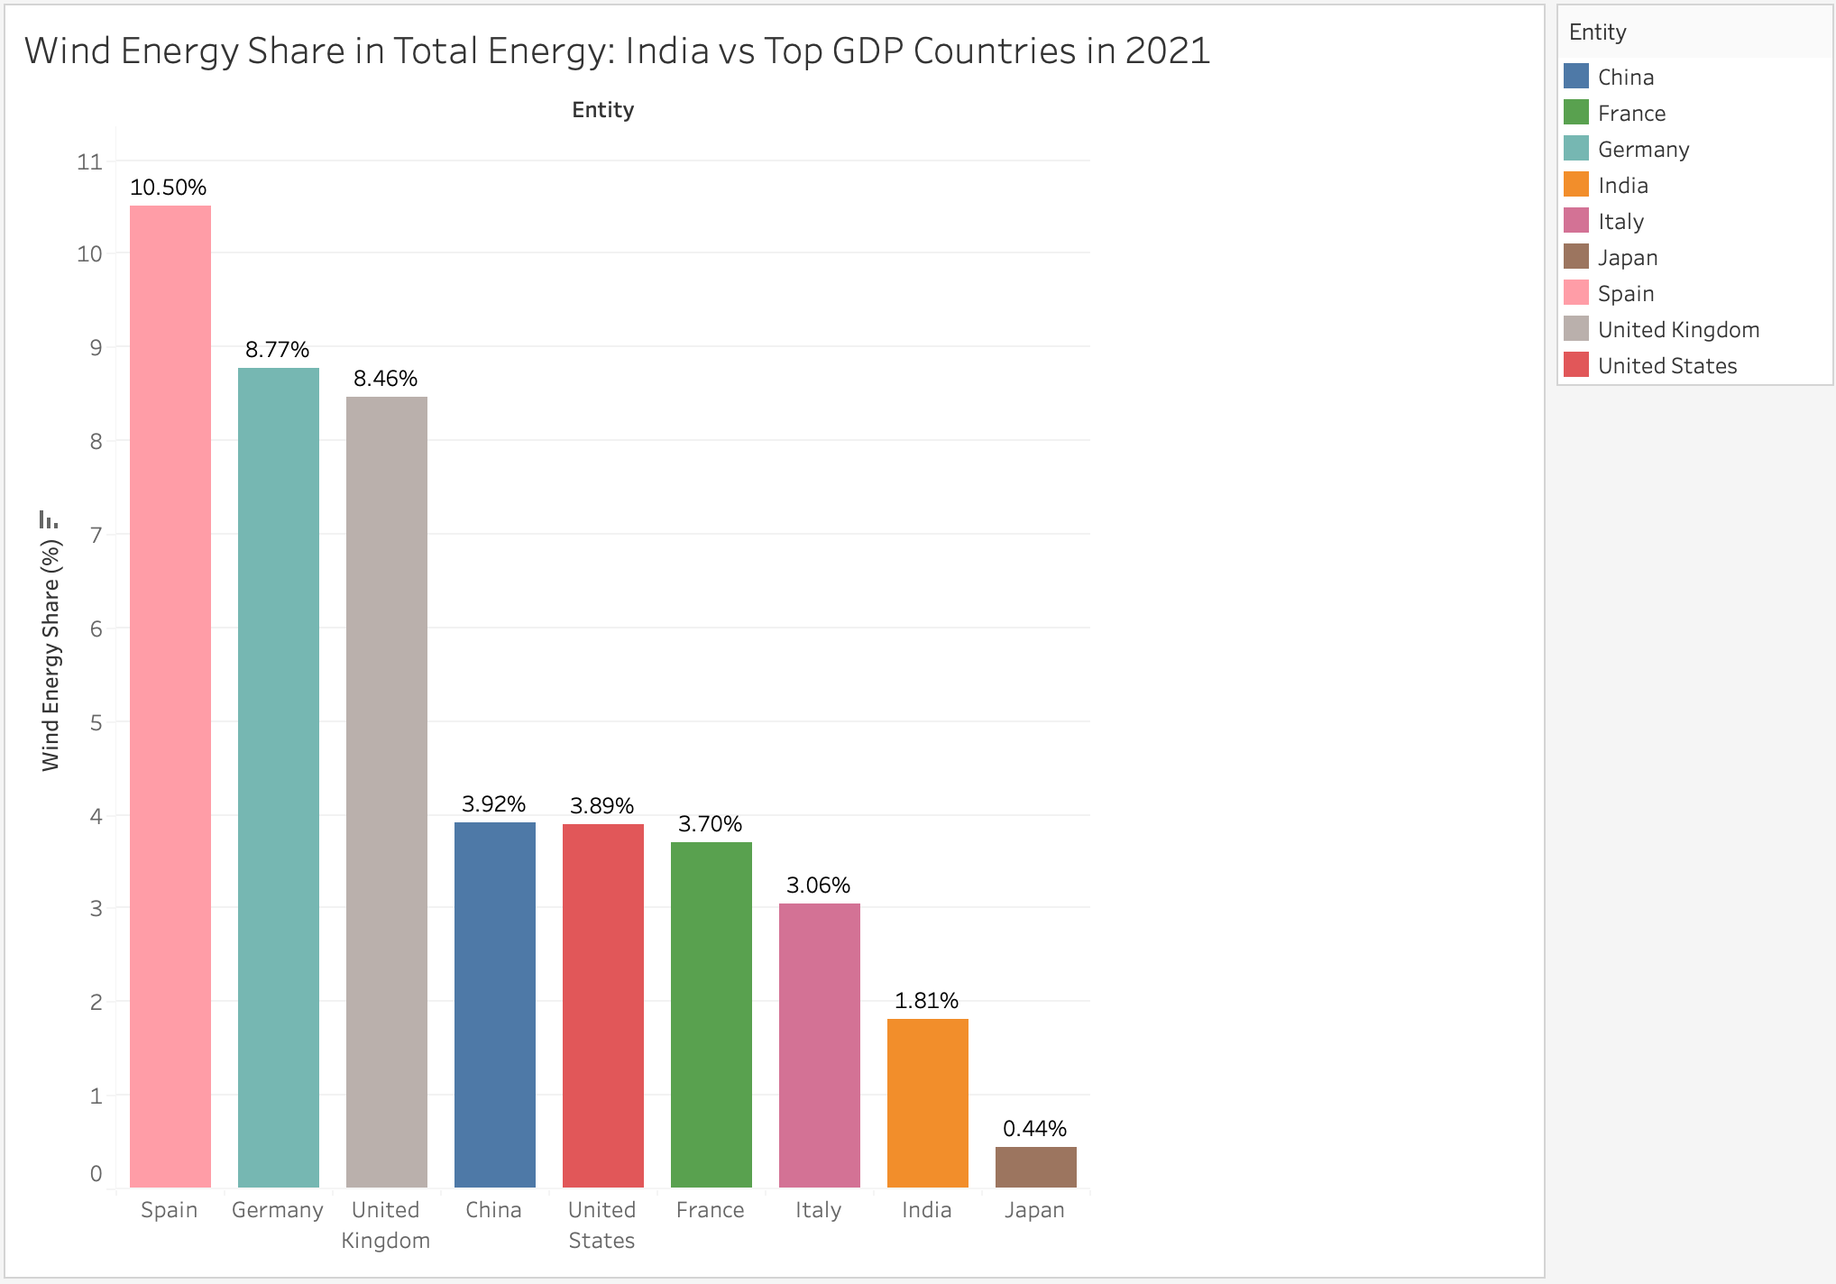

Similarly this bar graph depicts the analysis of wind energy share in total energy of the top GDP countries along with India. We can observe that despite being top two wind energy generators, China and the United States contribute only 3.92% and 3.89% respectively. India contributes about 1.81% and stands above Japan which has the lowest contribution of 0.44% wind energy share despite being one of the top GDP countries.

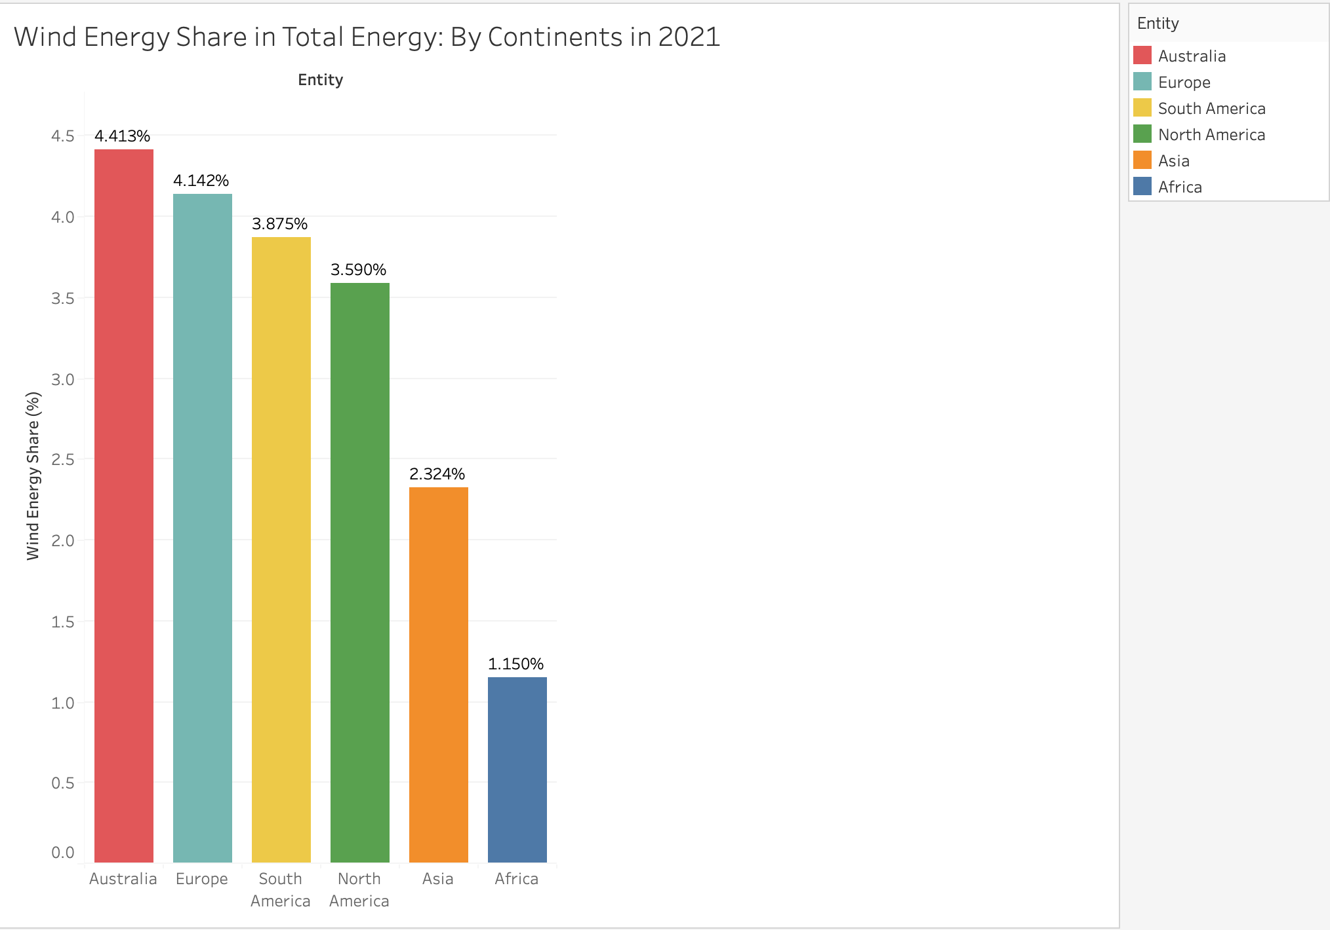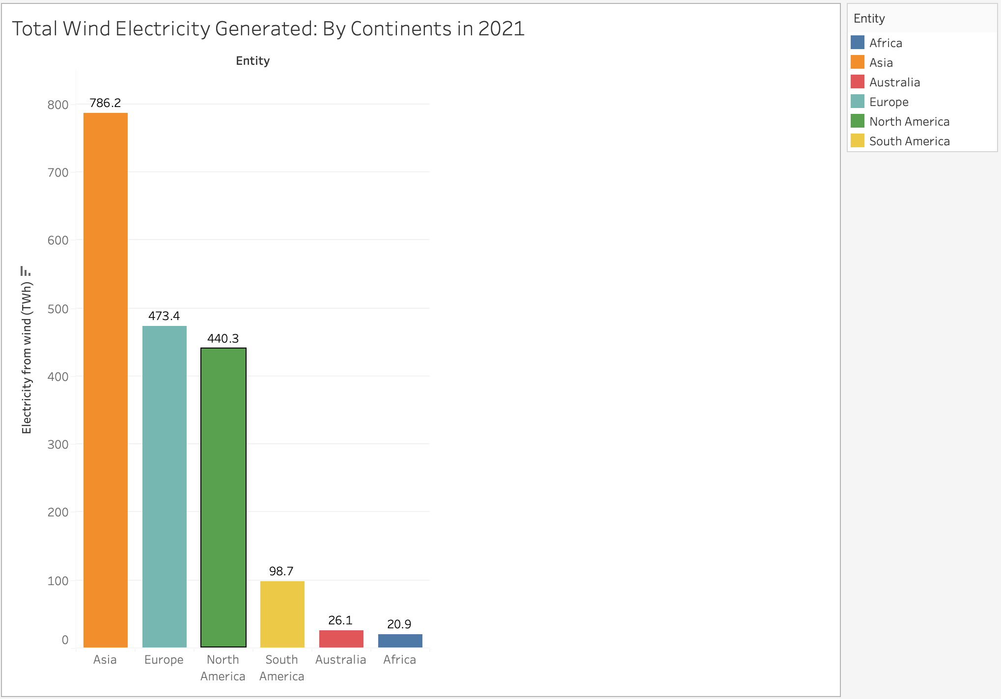

This is a comparison of total wind electricity generation and the share of wind energy in the total energy mix across continents for 2021. In terms of total wind electricity generation, Asia emerges as the leading continent, generating 786.2 TWh, followed by Europe and North America with 473.4 TWh and 440.3 TWh, respectively. South America, Australia, and Africa also contribute to wind electricity generation, albeit to a lesser extent. However, when considering the share of wind energy in the total energy mix, Australia takes the lead with the highest percentage share of 4.413%, followed closely by Europe and South America. North America, Asia, and Africa exhibit lower shares of wind energy in their total energy mixes, suggesting varying degrees of reliance on wind power across continents.

## 6. Solar power Energy

Datasets used : [12 solar-energy-consumption.csv](https://www.kaggle.com/datasets/belayethossainds/renewable-energy-world-wide-19652022/data?select=12+solar-energy-consumption.csv), [13 installed-solar-PV-capacity.csv](https://www.kaggle.com/datasets/belayethossainds/renewable-energy-world-wide-19652022/data?select=13+installed-solar-PV-capacity.csv), [14 solar-share-energy.csv](https://www.kaggle.com/datasets/belayethossainds/renewable-energy-world-wide-19652022/data?select=14+solar-share-energy.csv)

The Dataset contains the following columns:

* **Entity:** Contains 104 different regions (countries, continents, income brackets)
* **Code:** Contains region codes.
* **Year:** In the range 1965 - 2021
* **Electricity from solar (TWh):** The amount of electricity produced from solar energy
* **Solar (% equivalent primary energy):** Measures the percentage of solar energy within a nation's overall energy composition.
* **Solar Capacity:** Quantifies the energy potential harnessed, showcasing the evolution of solar power infrastructure and investment.

### a. World Solar Energy Generation:

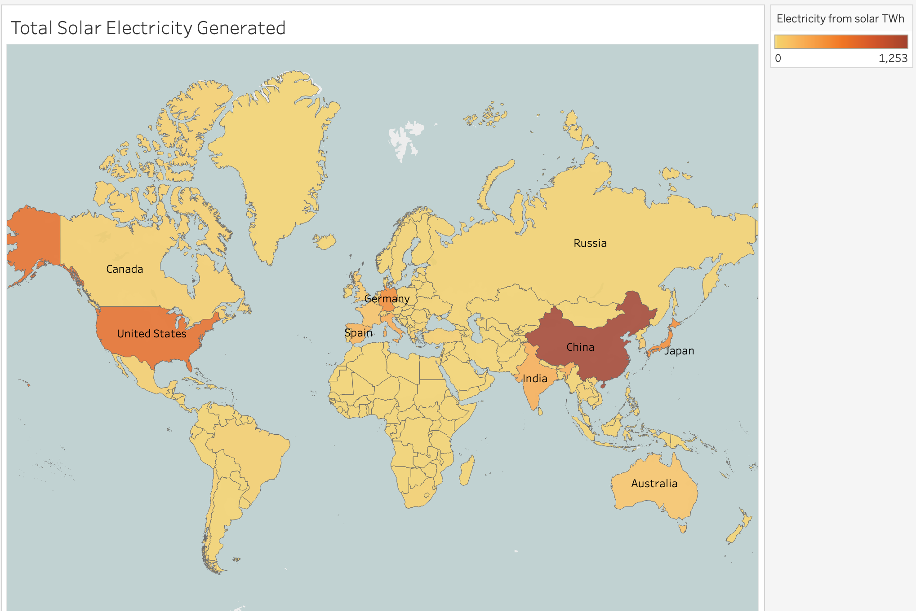

This visualization presents a world map illustrating the total solar energy generated across different countries. Each country is color-coded using different hues from red to yellow based on its percentage share of renewable energy in the total energy mix, with red showing high values and yellow showing lower values.

We can infer from the map that China, USA and Germany generate significantly high amounts of solar energy. In contrast, India's solar output appears moderately average, akin to Spain and Australia. Notably, African and South American nations exhibit lower levels of solar energy generation, underscoring regional disparities in renewable energy utilization.

### b. Total Solar Electricity Generation - By Continents:

These visualizations serve as reminders of the relatively recent emergence of solar energy generation, which gained momentum primarily in the late 2000s and was virtually nonexistent in the preceding century. Despite its growing prominence, solar generation continues to play a subordinate role compared to other renewable sources such as hydro and wind.

The dominance of Asia in solar electricity generation, contributing to a significant 56.44% of the world's total solar electricity output in 2021, underscores the region's concerted efforts to embrace and capitalize on solar technologies.

Conversely, Africa's minimal contribution to global solar energy production, as evidenced by the preceding world map, reflects the region's untapped potential and underscores the need for targeted investments and policy interventions to foster greater solar adoption and address energy poverty in the continent.

### c. Total Solar Electricity Generation - Top 10 Countries (since 2010):

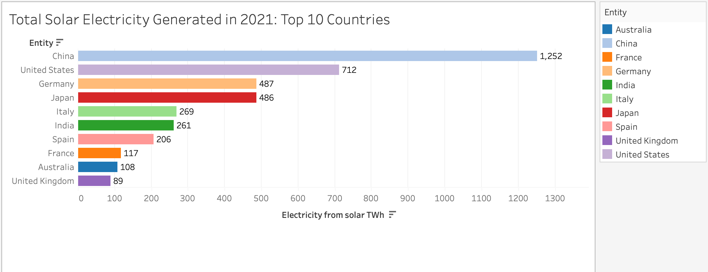

As demonstrated in the preceding visual representations, Asia leads in solar electricity generation, with China notably contributing the highest amount, totaling 1,252 TWh in 2021. Additionally, other Asian nations like India and Japan also play significant roles in this substantial generation, with India having produced 261 TWh of solar electricity in 2021.

### d. Total Solar Energy Generation - Comparing India with select other countries

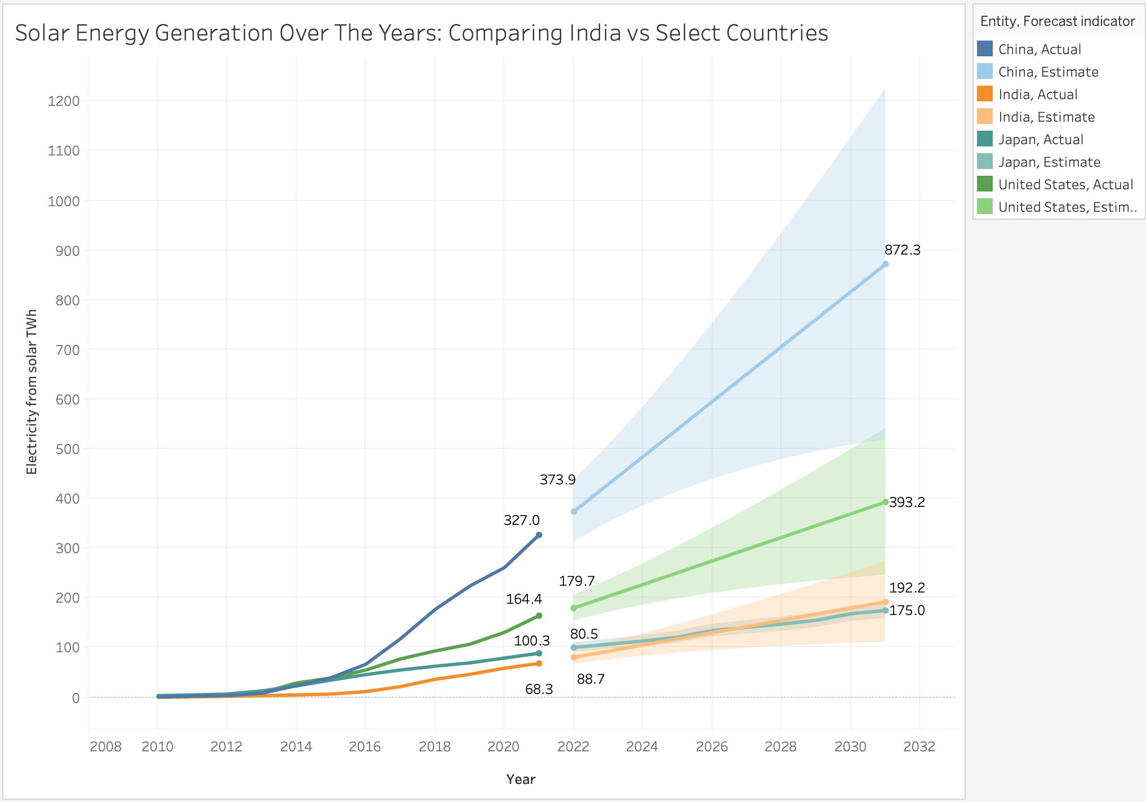

The graph shows a significant increase in solar energy generation for all countries, with China leading significantly in both actual and predicted figures. India shows a steady rise with a notable increase in estimated generation after 2020. The United States and Japan also show growth, but at a slower rate compared to China and India. The model forecasts that India will have an increase of 192.2 TWh in 2032 from 88.7TWh in 2022 (total increase of 103.5 TWh). Though India remains subordinate to other top GDP countries, it will surely see a steady increase in its solar energy generation in the upcoming years.

### e. Total Solar Electricity Generation - Comparison of the last two decades of select countries

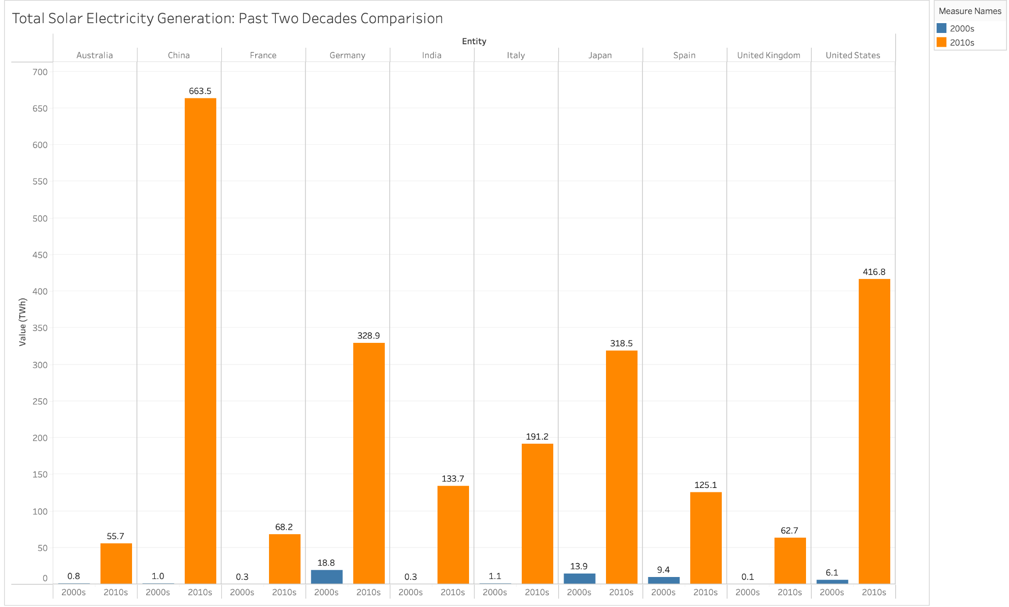

The illustrated bar chart presents a comparative examination of solar electricity generation between the 2000s and 2010s across various nations, offering valuable insights into the impact of recent technological advancements on this trend. Noteworthy is India's modest rise of 133.5 TWh in solar electricity generation during the 2010s compared to the preceding decade. Conversely, China stands out with a substantial overall increase of 662.5 TWh, highlighting the considerable influence of technological progress and infrastructure development on solar expansion within the region. Overall, all countries have experienced a significant increase in solar electricity production over the past decade.

### e. Solar Energy Capacity as of 2021: Top 10 Countries:

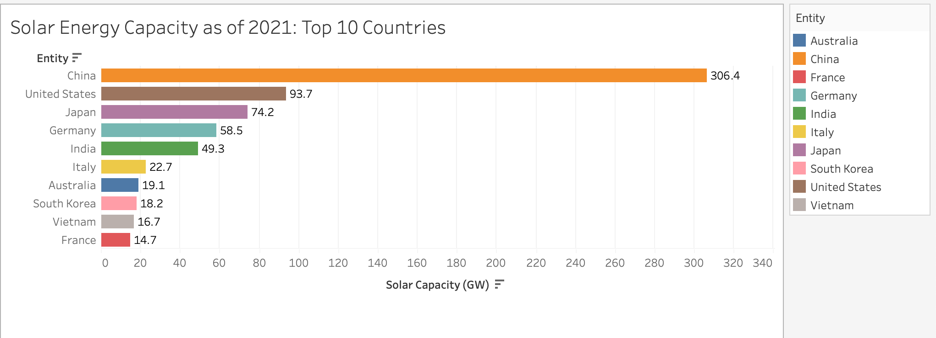

The bar chart depicting Solar Energy Capacity as of 2021 for the top 10 countries reveals a clear dominance of China in solar energy infrastructure, with a capacity of 306.4 GW, significantly surpassing other nations. The United States follows as a distant second with 93.7 GW, highlighting a considerable gap between the top two leaders. India holds the fifth position with a capacity of 49.3 GW, demonstrating notable progress in solar energy adoption.

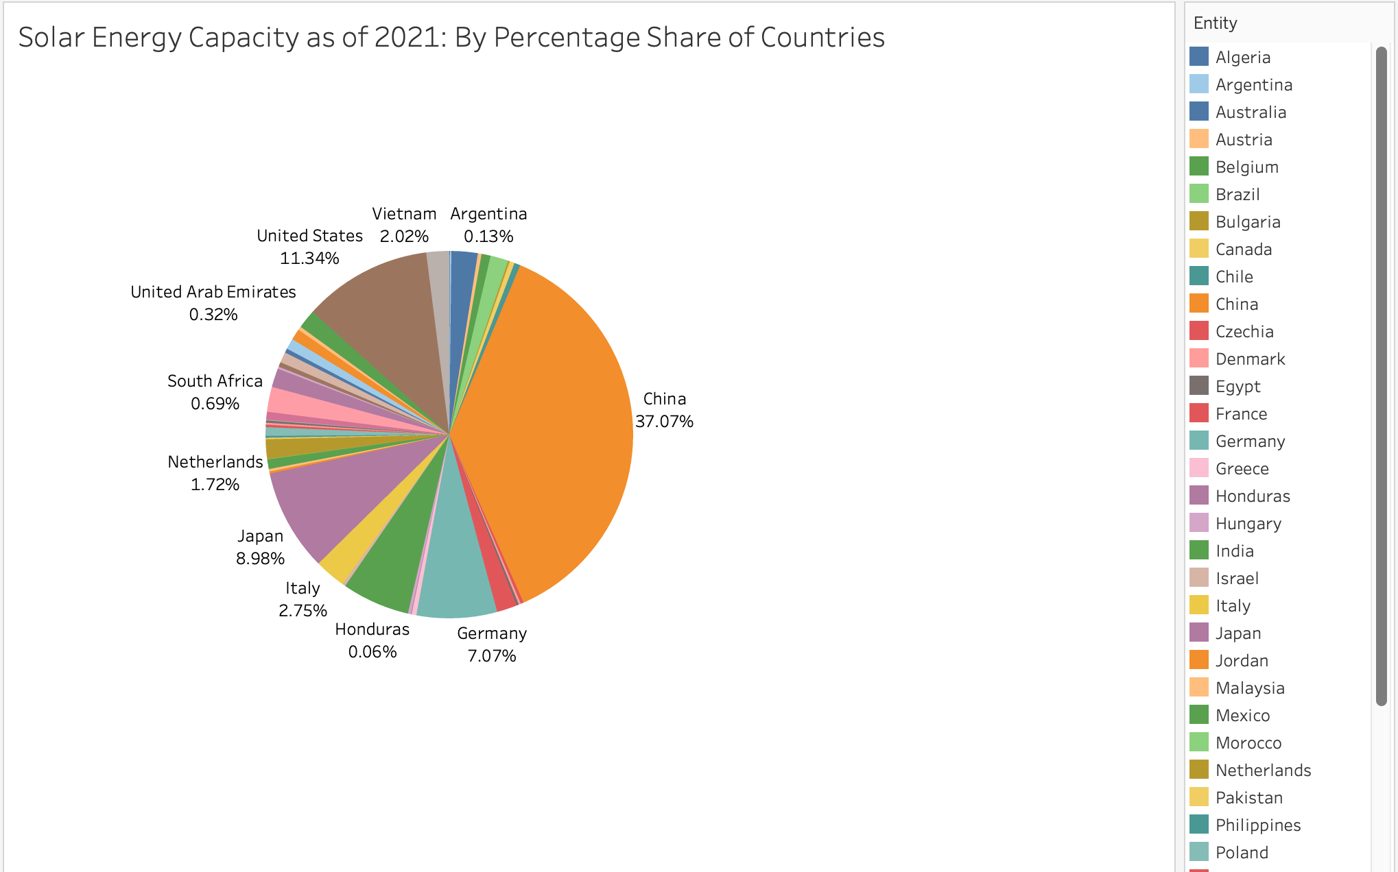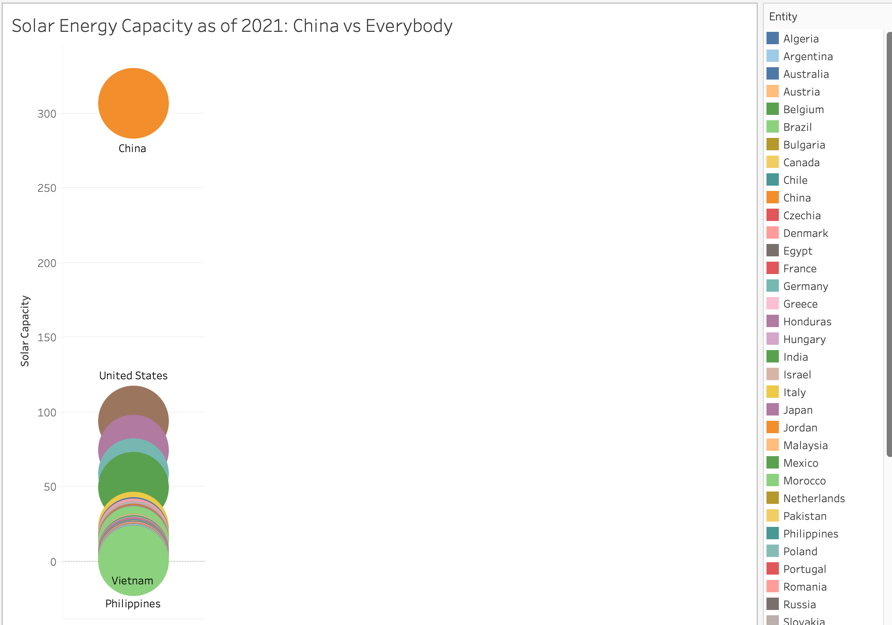

The data presented in the two charts unmistakably highlights China's unparalleled dominance in solar energy infrastructure, standing head and shoulders above all other nations. China's substantial lead underscores its proactive approach and significant investments in renewable energy development, positioning it as a global leader in the solar energy sector. This remarkable infrastructure not only reflects China's commitment to sustainability but also serves as a testament to its technological advancements and economic prowess. However, while China sets the benchmark for solar energy capacity, it also offers an opportunity for other nations to learn and collaborate in advancing renewable energy initiatives. The charts underscore the urgent need for other countries to accelerate their efforts and investments in solar energy infrastructure to bridge the gap and collectively combat climate change while transitioning towards a more sustainable energy future.

### f. Solar Energy Capacity as of 2021: By Percentage Share of Continents

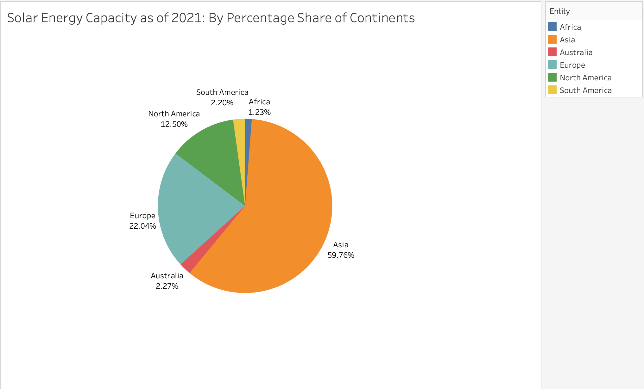

Asia maintains a commanding lead in solar energy capacity, boasting a significant 59.76% share, while Europe follows with 22.04%. China's prominence, coupled with contributions from Japan and India, solidifies Asia's dominance, accounting for nearly two-thirds of the total global solar capacity.

### g. Solar Energy Share in Total Energy in 2021:

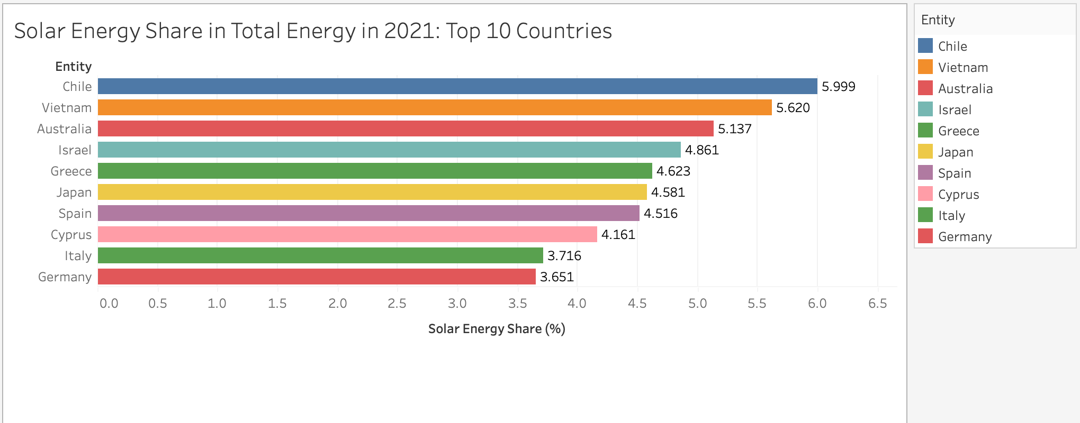

A notable observation is that while China leads in solar energy generation, its proportion of solar energy relative to total energy generation is relatively low, influenced by its large population and extensive infrastructure needs. Conversely, countries like Chile, Vietnam, Australia, and Israel exhibit a higher percentage of solar energy in their total primary energy mix, with Chile leading at 5.99%.

### h. Solar Energy Share in Total Energy in 2021: India vs Top GDP Countries

### 

The above bar chart compares the percentage share of solar energy in the total energy mix for Top GDP countries in 2021. From the chart, India's solar energy share in 2021 is represented as 1.816%. This places India in the middle range among the countries displayed. The highest solar energy share is observed in Japan at 4.581%, followed closely by Spain at 4.516%. On the lower end, France has a solar energy share of 1.463%. This indicates a considerable investment and utilization of solar energy within India's energy portfolio relative to its global peers.

### i. Solar Energy Share Over The Years: India vs Top GDP Countries

When we look at the trend over the years, it's evident that all the top GDP countries have experienced a gradual rise in their solar energy utilization since the 2010s. While India has shown a minimal increase, Spain, Japan, Germany, and Italy have witnessed significant growth in this regard.

### 

The line chart above showcases future predictions for the rise in solar energy utilization up to the year 2031 for India and other leading GDP nations: China, Japan, and the USA. According to our model, India is predicted to overtake China by approximately 2026. Meanwhile, Japan is expected to maintain a consistent upward trajectory, surpassing other countries in its solar energy share.

### j. Solar Energy Share in Total Energy in 2021: By Continent

This is a comparison of total solar energy generation and the share of solar energy in the total energy mix across continents for 2021.In terms of total solar energy generation, Asia emerges as the leading continent, generating 587.0 TWh, followed by North America and Europe with 188.2 TWh and 187.7 TWh, respectively. South America, Australia, and Africa also contribute to solar energy generation, although to a lesser extent. However, when considering the share of solar energy in the total energy mix, South America stands out with the highest percentage share of 5.137%, followed by Australia and Europe. Asia, North America, and Africa exhibit comparatively lower shares of solar energy in their total energy mixes

## 7. Biofuel and Geothermal power Energy

Datasets used : [16 biofuel-production.csv](https://www.kaggle.com/datasets/belayethossainds/renewable-energy-world-wide-19652022/data?select=16+biofuel-production.csv), [17 installed-geothermal-capacity.csv](https://www.kaggle.com/datasets/belayethossainds/renewable-energy-world-wide-19652022/data?select=17+installed-geothermal-capacity.csv)

The Dataset contains the following columns:

* **Entity:** Contains 104 different regions (countries, continents, income brackets)
* **Code:** Contains region codes.
* **Year:** In the range 1965 - 2021
* **Biofuels Production - TWh - Total:** The amount of biofuel energy produced.
* **Geothermal Capacity (MW):** Quantifies the installed capacity, reflecting the advancements in geothermal energy infrastructure and investments.

These bar charts show the clear dominance of the United States in both the areas - Biofuel Energy Generation and Geothermal Capacity. It should also be noted that both these fields are still in their very nascent stages and not a lot of countries have started investing into these renewable energy forms. But the United States clearly believes in them and hence has invested significant resources early, perhaps hoping for great returns in the future. India on the other hand has yet to really buy into these two renewable energy sources. 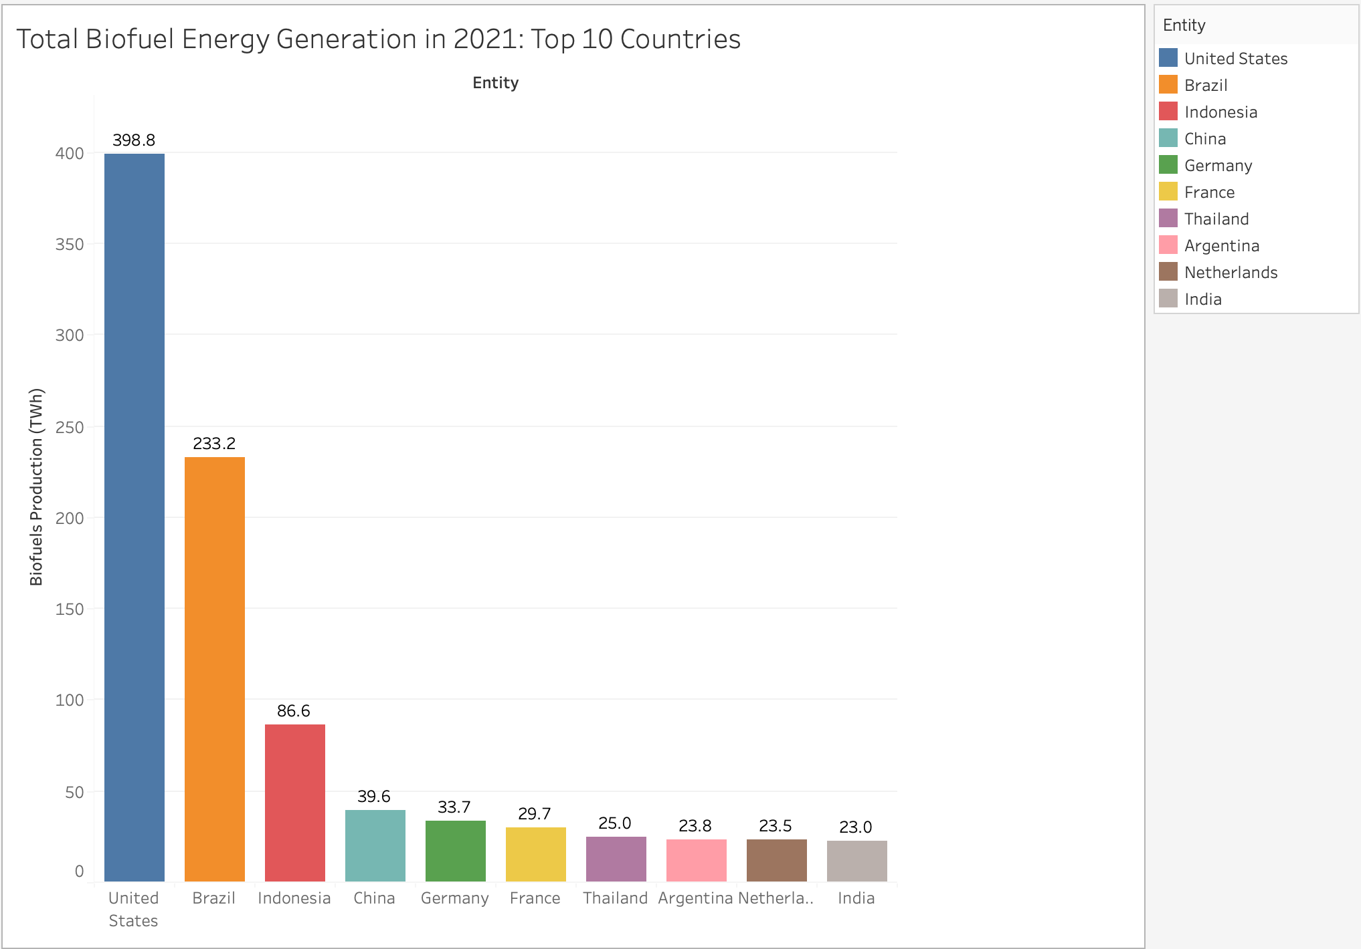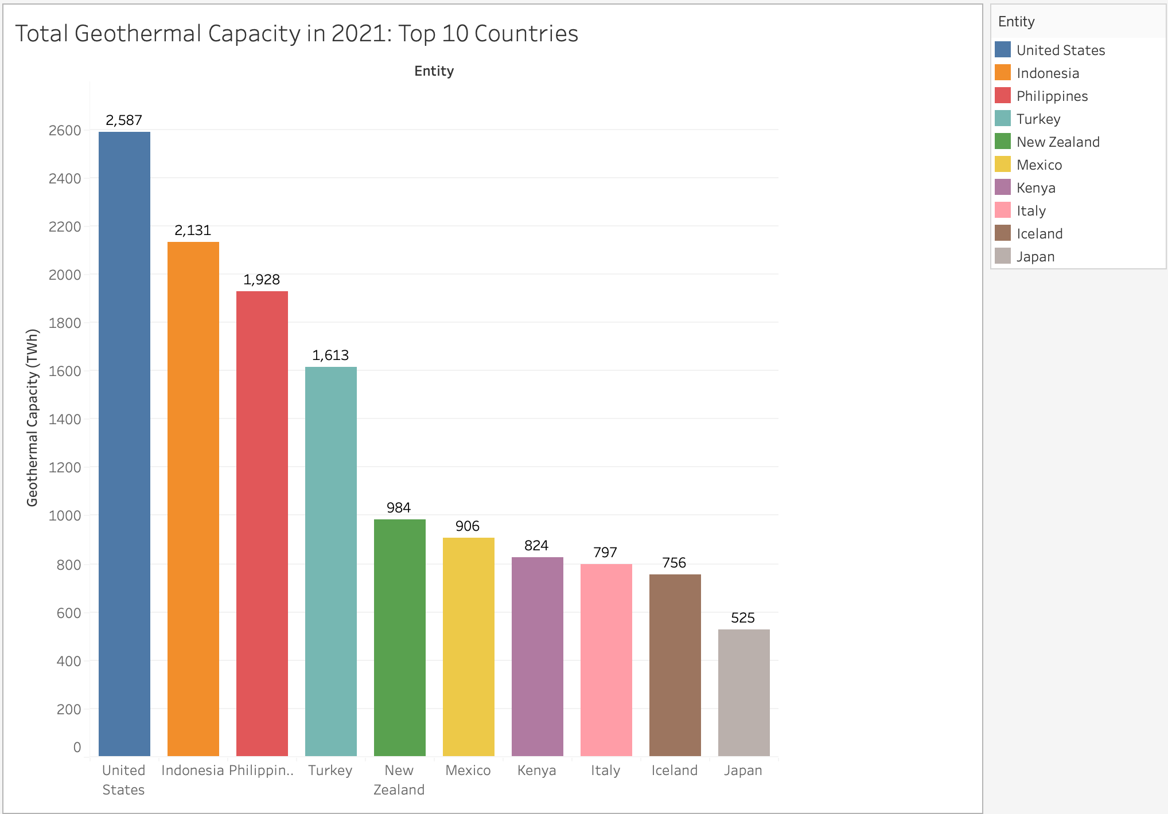

# 

# 

# Conclusion

In this project we have provided a comprehensive analysis of the global renewable energy landscape, with a specific focus on comparing India's position against other countries, continents, and income brackets. India has made significant strides in renewable energy deployment, although there are disparities compared to global benchmarks. While the country has shown progress, being among the top 10 countries in renewable energy generation, there are challenges to address in order to further enhance its renewable energy portfolio, and meet its energy and sustainability demands. Certain renewable energy technologies, such as hydro, solar, wind, geothermal, and biomass, exhibit varying levels of prominence across different regions, with hydro being the dominant renewable energy generated. Understanding these variations can inform strategic planning and resource allocation for renewable energy development. We have also concluded that there exists a direct correlation between a country’s GDP and the percentage of renewable energy generated by that country. The study highlighted regional disparities in renewable energy adoption and policy frameworks, emphasizing the importance of tailored approaches to address specific challenges and opportunities within different geographical contexts. Predictive models indicate a positive trend in global renewable energy adoption, with significant potential for growth in both developed and developing regions. Strategic investments and supportive policies are crucial to capitalize on this potential. By examining successful models from countries like China, Brazil, and Iceland, other nations can gain valuable insights and lessons to enhance their own renewable energy policies and contribute to global efforts in combating climate change and promoting energy sustainability.

# 

# References

[1] Yolcan, O. O. (2023). World energy outlook and state of renewable energy: 10-Year evaluation. *Innovation and Green Development*, *2*(4), 100070.

[2] Ang, T. Z., Salem, M., Kamarol, M., Das, H. S., Nazari, M. A., & Prabaharan, N. (2022). A comprehensive study of renewable energy sources: Classifications, challenges and suggestions. *Energy Strategy Reviews*, *43*, 100939.

[3] IEA (2021), Global Energy Review 2021, IEA, Paris https://www.iea.org/reports/global-energy-review-2021, Licence: CC BY 4.0

[4] Ashwani Kumar, Kapil Kaushik, Naresh Sharma, Satyawati Mishra, Saroj. (2010). Renewable energy in India: Current status and future potentials. Renewable and Sustainable Energy Reviews. 14. 2434-2442. 10.1016/j.rser.2010.04.003.

[5] Dey, S., Sreenivasulu, A., Veerendra, G. T. N., Rao, K. V., & Babu, P. A. (2022). Renewable energy present status and future potentials in India: An overview. Innovation and Green Development, 1(1), 100006.

[6] HamoyeHQ, Global Renewable Energy Transition Analysis and Forecast. (2024). Medium.

[7] <https://www.mordorintelligence.com/industry-reports/global-renewable-energy-market-industry>

[8] <https://www.spglobal.com/esg/s1/topic/indian-renewable-energy-data-analytics.html>

[9] Mentel, G., Lewandowska, A., Berniak-Woźny, J., & Tarczyński, W. (2023). Green and renewable energy innovations: a comprehensive bibliometric analysis. Energies, 16(3), 1428.

[10] Deshmukh, M. K. G., Sameeroddin, M., Abdul, D., & Sattar, M. A. (2023). Renewable energy in the 21st century: A review. Materials Today: Proceedings, 80, 1756-1759.

[11] Vijay Kumar Vaddadi (2023). Wind Energy in India – An Overview. SAS Partners.